**PHP Internship Report**

**Personal Details**

Name : Rameshwar Ishnava

College name : Govt. Polytechnic Jamnager

Degree : Diploma Computer

Semester : 6

Github URL : <https://github.com/Rameshwar-Ishnava>

**Company Details**

Company name : Akash Technolabs

External Guide : Akash Padhiyar

Training Duration : 26 May 2021 To 21 June 2021

Index

Day 1 4

Learn Basic php and html tag. 4

Day 2: 16

Understand the PHP 16

Variables, if...else, Switch case, For Loop, Date & Time Function, Math Functions in PHP. 16

Day 3 18

Students Marks Entry Form Using PHP 18

For Loop program using Table Tag 18

Registration Form Using get and post method 18

Day 4 20

PHP Template Integration 20

Day 5 & 6 23

Remaining work in Template 1 & 2 23

Day 7 24

Numerical , Associative Array 24

Day 8 25

Database connection ,insertion operation 25

perform insertion operation without theme 25

perform insertion operation with theme 25

Day 9 & 10 27

select, delete & update query 27

fetching data from database 27

redirection on page 27

update query and embed into theme. 27

Perform update operations on table 27

Day – 11 ,12, 13,14, 15 30

Installation and learing about wordpress 30

Features and defects of wordpress 30

undarstanding a wordpress development environment. 30

simple blog creation using wordpress 30

Installation of plugins and use of it 30

menus creation in theme 30

Theme customization and development in wordpress 30

## Day 1

### Learn Basic php and html tag.

**Code:**

**<html>**

**<haed>**

**<body style="background-color:powderblue;">**

**<style>**

**#t {background-color:purple;color:white;padding:5px 60px;}**

**p1 {color:green;font-size:20px;}**

**p2 {color:red;font-size:20px;}**

**p4 {color:blue; font-size:20px;}**

**#footer { background-color: lightgreen; color:darkorange; padding: 10px; text-align: center;}**

**#Header {background-color: lightgreen; color: black;padding: 10px; text-align: center;}**

**#H2{color:green;font-size:30px;}**

**#f{font-size:30px;}**

**</style>**

**<title>Attecker</title>**

**<div class="t">**

**<a id="t" href="table.html">HOME</a>**

**<a id="t" href="about.html">ABOUT</a>**

**<a id="t" href="contact.html">CONTACT</a>**

**<a id="t">ARTICLES</a>**

**<a id="t">COURSE</a>**

**</div>**

**<p> click HOME and Open College time table </p>**

**<h1 id="footer" align="center">Cyber Security</h1>**

**<h2>**

**<li type="1">**

**What is Cyber Security?**

**</li>**

**</h2>**

**<li type="circle">**

**<img src="C:\Users\DSC\Downloads\What-is-Cyber-Security.jpg" align="right" alt="cyber security image">**

**<p1>**

**Cyber security refers to the body of technologies,**

**processes, and practices designed to protect networks,**

**devices, programs, and data from attack, damage, or unauthorized access.**

**<br>**

**<br>**

**<li type="circle">Cyber security may also be referred to as information technology security<br>**

**</p1><br>**

**<br>**

**<li type="circle">**

**<p2> Cybersecurity is the practice of protecting systems, networks,**

**and programs from digital attacks. <br>**

**</p2><br><br>**

**<li type="circle">**

**<p3>**

**These cyberattacks are usually aimed at accessing,**

**changing, or destroying sensitive information;**

**extorting money from users; or interrupting normal business processes.<br>br>**

**</p3><br>**

**<li type="circle">**

**<p4> Implementing effective cybersecurity measures is particularly**

**challenging today because there are more devices than people, and attackers**

**are becoming more innovative.<br><br>**

**</p4>**

**</li>**

**<a id="f" href="https://www.cisco.com/c/en/us/products/security/what-is-cybersecurity.html">more information link</a>..this is enternal link<br><br>**

**<a id="H2" href="https://www.youtube.com/watch?v=ooJSgsB5fIE" target="_blank">youtube link</a>... this is external link<br>**

**<h2 id="Header" align="center">thank you visit my page</h2>**

**<footer>**

**<span>Rameshwar(C) All rights Reserved</span>**

**</footer>**

**</haed>**

**</html>**

**Main page**

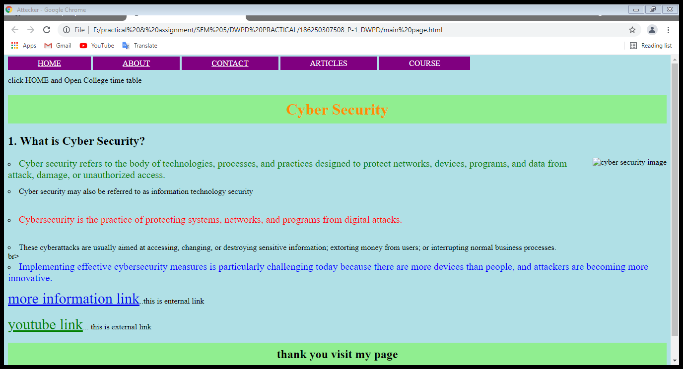

**About page**

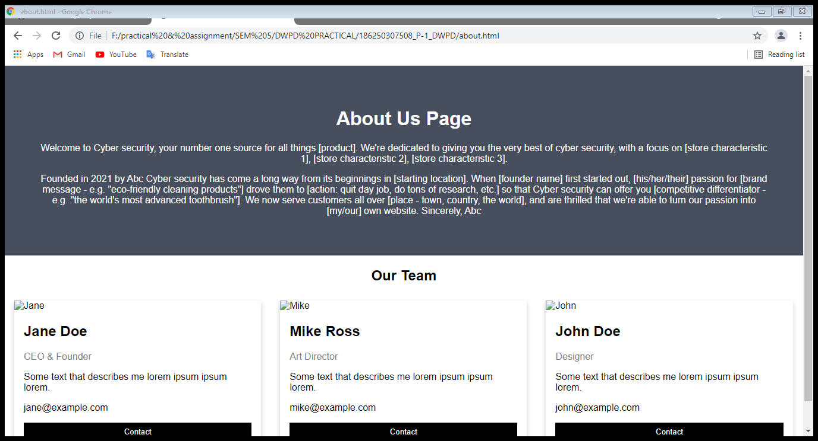

**Contact page Code:**

**<!DOCTYPE html>**

**<html>**

**<head>**

**<meta name="viewport" content="width=device-width, initial-scale=1">**

**<style>**

**body {font-family: Arial, Helvetica, sans-serif; background-color: #f99bcd}**

**\* {box-sizing: border-box;}**

**input[type=text], select, textarea {**

**width: 25%;**

**padding: 12px;**

**border: 1px solid #ccc;**

**border-radius: 4px;**

**box-sizing: border-box;**

**margin-top: 6px;**

**margin-bottom: 16px;**

**resize: vertical;**

**}**

**input[type=submit] {**

**background-color: #04AA6D;**

**color: white;**

**padding: 12px 20px;**

**border: none;**

**border-radius: 4px;**

**cursor: pointer;**

**}**

**input[type=submit]:hover {**

**background-color: #45a049;**

**}**

**.container {**

**border-radius: 5px;**

**background-color: #9571d4;**

**padding: 20px;**

**}**

**</style>**

**</head>**

**<body>**

**<h3>Contact Form</h3>**

**<center>**

**<div class="container">**

**<form action="#">**

**<label for="fname">First Name</label>**

**<input type="text" id="fname" name="firstname" placeholder="Your name..">**

**<br>**

**<label for="lname">Last Name</label>**

**<input type="text" id="lname" name="lastname" placeholder="Your last name..">**

**<br>**

**<label for="country">Country</label>**

**<select id="country" name="country">**

**<option value="australia">Australia</option>**

**<option value="canada">Canada</option>**

**<option value="usa">USA</option>**

**</select>**

**<br> <label for="subject">Subject</label><br>**

**<textarea id="subject" name="subject" placeholder="Write something.." style="height:200px"></textarea>**

**<br><input type="submit" value="Submit">**

**</form>**

**</div>**

**</center>**

**</body>**

**</html>**

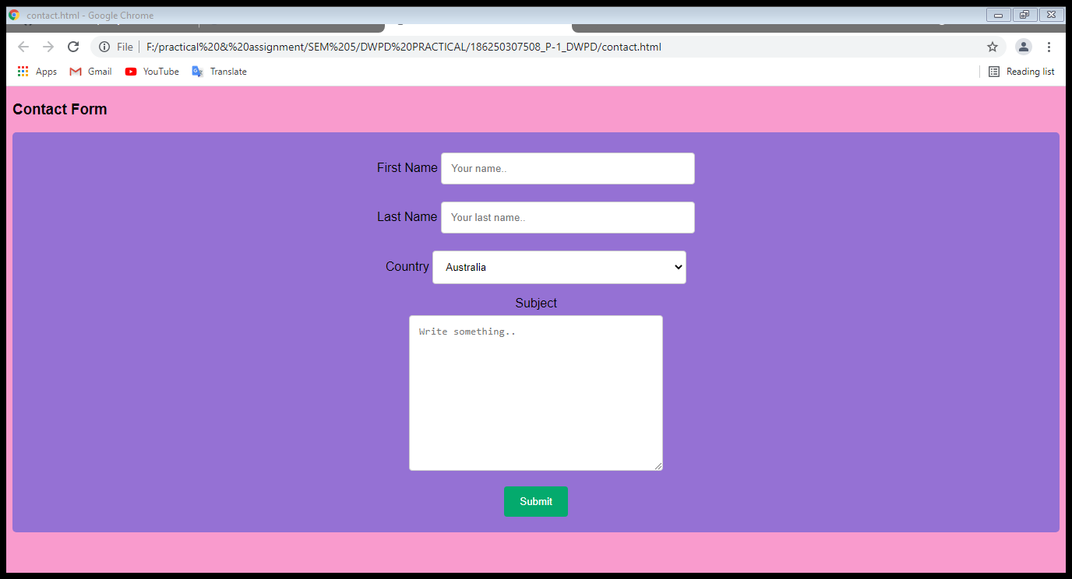

**Table create page:**

**Code:**

**<!DOCTYPE html>**

**<html>**

**<head>**

**<title>TIME TABLE</title>**

**</head>**

**<style>**

**#h1 {color:blue; background-color:darkorange; text-align:center;}**

**#h11{color:yellow;background-color:red; text-align:center;}**

**#h2{ color:white; background-color:darkgreen; text-align:center; }**

**#L {color:black; background-color:skyblue;}**

**#c {color:black; background-color:white;}**

**</style>**

**<body> <center>**

**<h1 id="h1">Goverment polytechnic Jamnagar</h1>**

**<h1 id="h2">Computer department</h1>**

**<h2 id="h3">COLLEGE TIME TABLE</h2>**

**<table width="700" border="01">**

**<tr bgcolor="darkorange" align="center">**

**<th>Time</th>**

**<th>Monday</th>**

**<th>Tuesday</th>**

**<th> Wednesday</th>**

**<th> Thursday</th>**

**<th>Friday</th>**

**</tr>**

**<tr>**

**<tr align="center">**

**<td id="c">10:30 To 11:30 </td>**

**<td id="h11" rowspan="3"align="center">ADBMS<br>+<br>.NET<br><br>**

**<td>FSD</td>**

**<td>FSD</td>**

**<td id="h11" rowspan="4"align="center">ADBMS<br>+<br>WDT<br><br>**

**<td id="h11" rowspan="4" align="center">.Net<br>+<br>WDT<br>**

**</tr>**

**<tr>**

**<tr align="center">**

**<td> 11:30 To 12:30</td>**

**<td>ADBMS</td>**

**<th id="h11" rowspan="4" align="center">CN<br>+<br>.Net<br>**

**</tr>**

**<tr><tr align="center">**

**<td>12:30 To 01:30</td>**

**<td>FSD</td>**

**<td id="h11"> FSD+ADBMS+WDT</td>**

**<td>FSD</td>**

**<td>ADBMS</td>**

**</tr>**

**<tr><tr align="center">**

**<td id="L">01:30 To 02:00 </td>**

**<td id="L" colspan="5" align="center"><p>L U N C H T I M E</p>**

**</tr><tr><tr align="center">**

**<td>02:00 To 03:00</td>**

**<td>COA</td>**

**<td id="h11"> FSD+ADBMS+WDT</th>**

**<td>COA</td>**

**<td>ADBMS</td>**

**<td>CN</td>**

**</tr>**

**<tr><tr align="center">**

**<td>03:00 To 04:00</td>**

**<td>CN</td>**

**<td id="h11" rowspan="4" align="center"> FSD+.NET+WDT</td>**

**<td id="h11" rowspan="4" align="center"> FSD+.NET+WDT</td>**

**<td> .NET</td>**

**<td id="h11" rowspan="4" align="center"> FSD+.NET+WDT</td>**

**</tr>**

**<tr><tr align="center">**

**<td> 04:00 To 05:00</td>**

**<td> .NET </td>**

**<td>cn</td>**

**</table>**

**</body>**

**</html>**

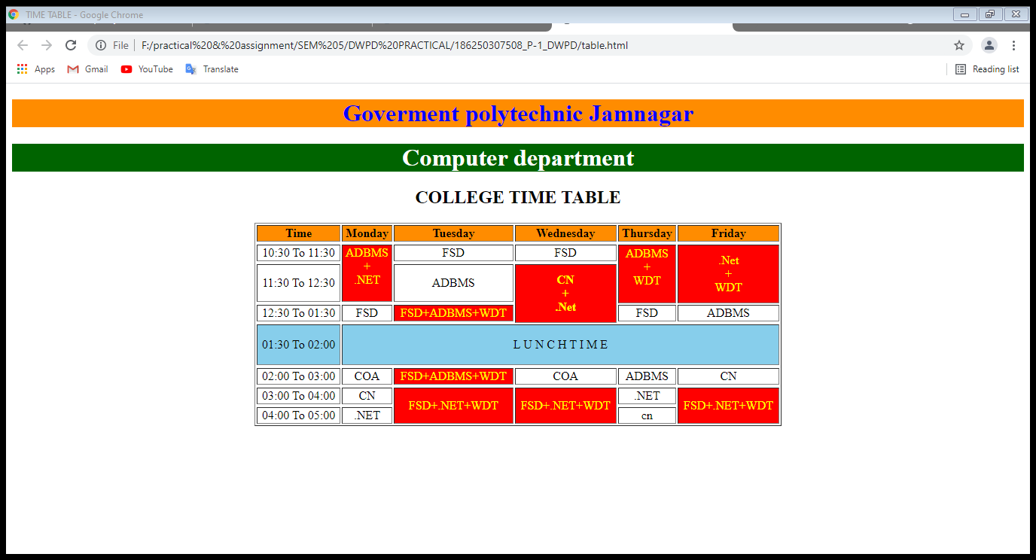

## Day 2:

### Understand the PHP

### Variables, if...else, Switch case, For Loop, Date & Time Function, Math Functions in PHP.

* If else and variable.

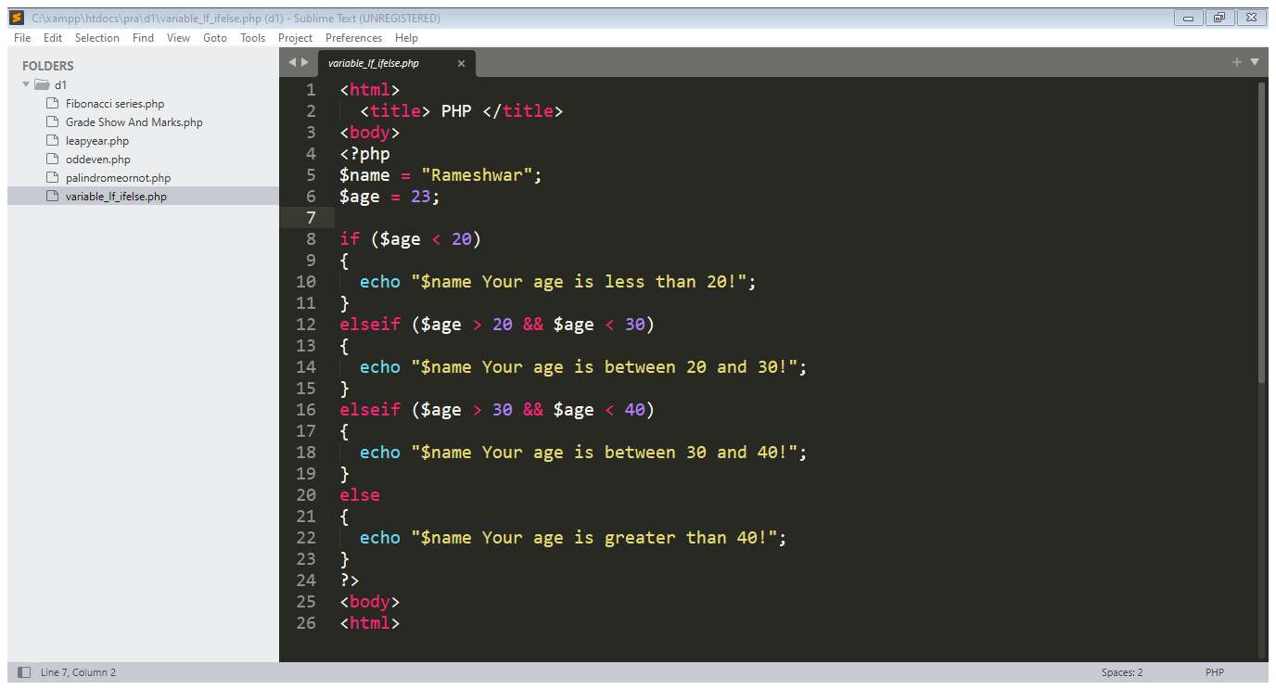

output

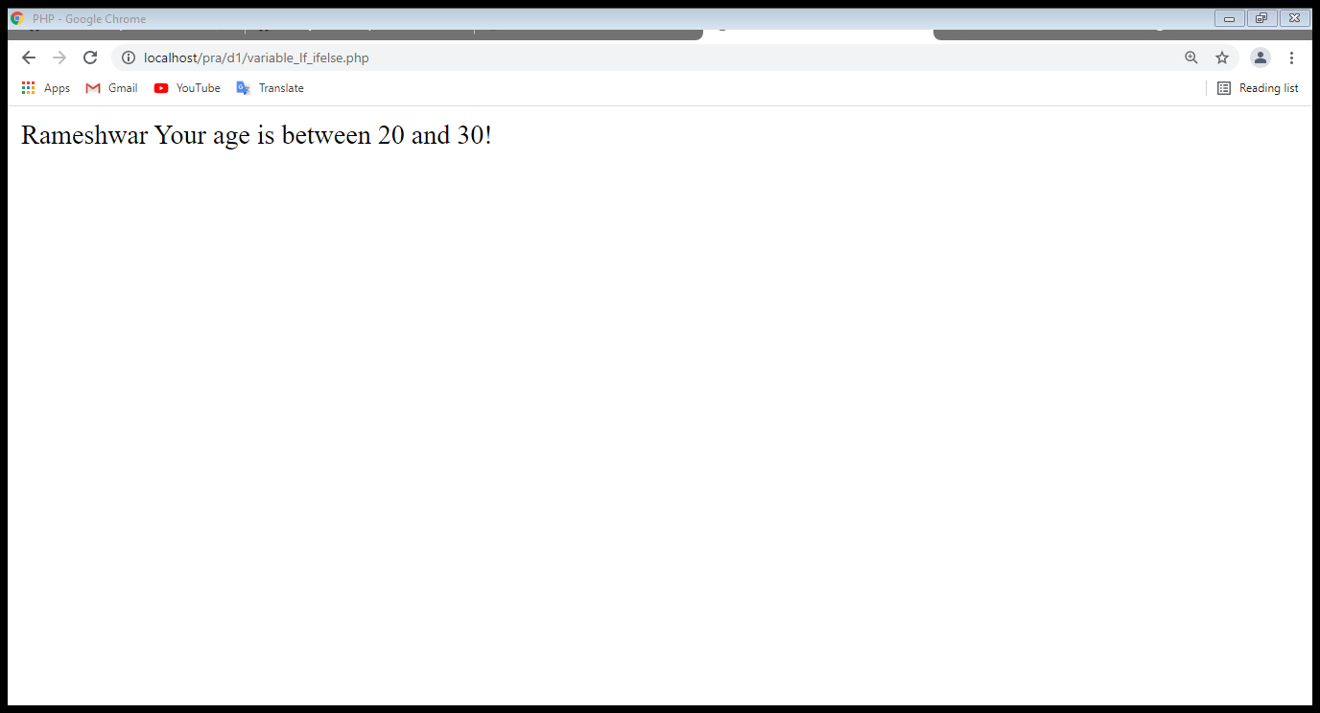

Switch case:

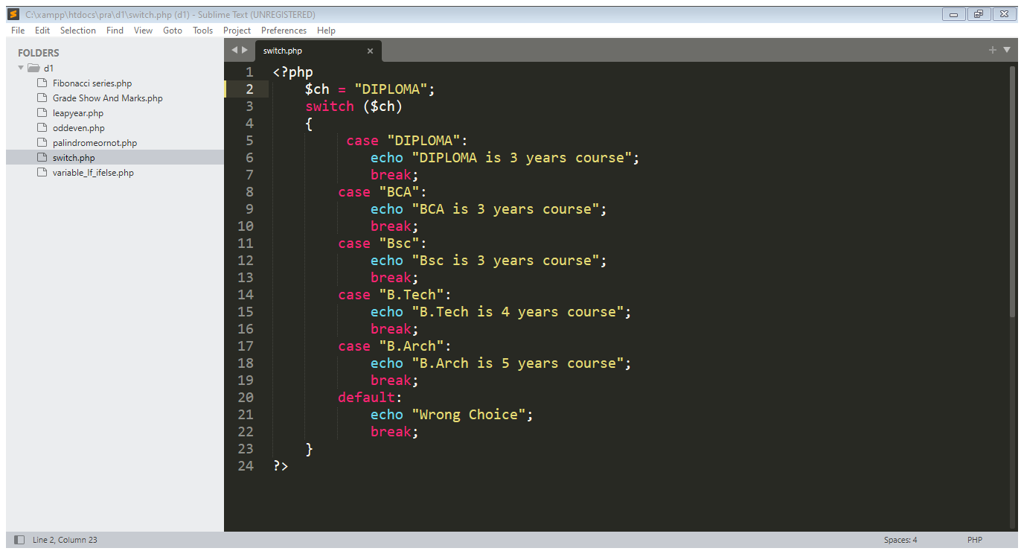

**output**

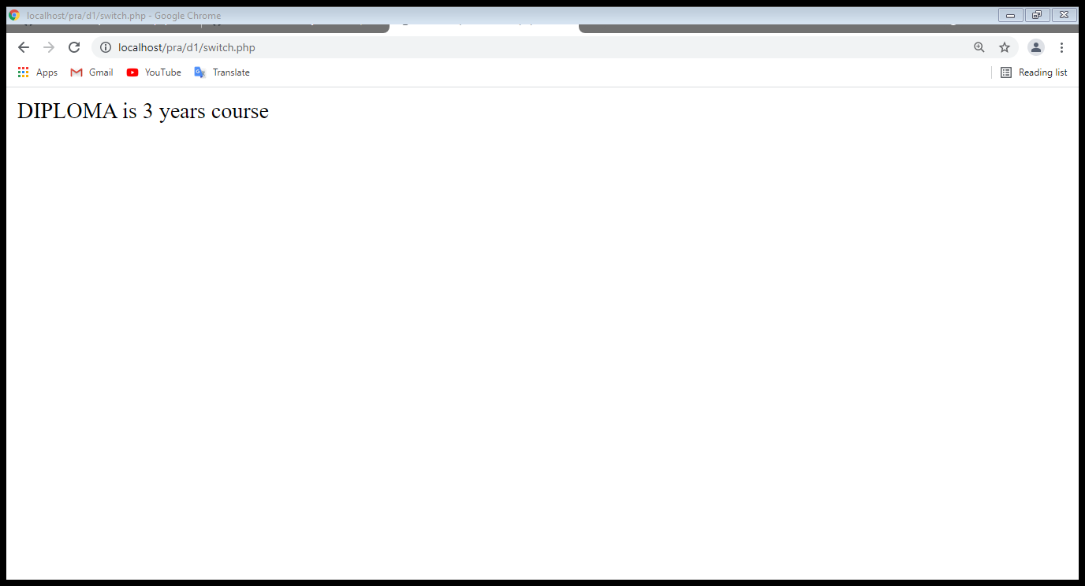

Function:

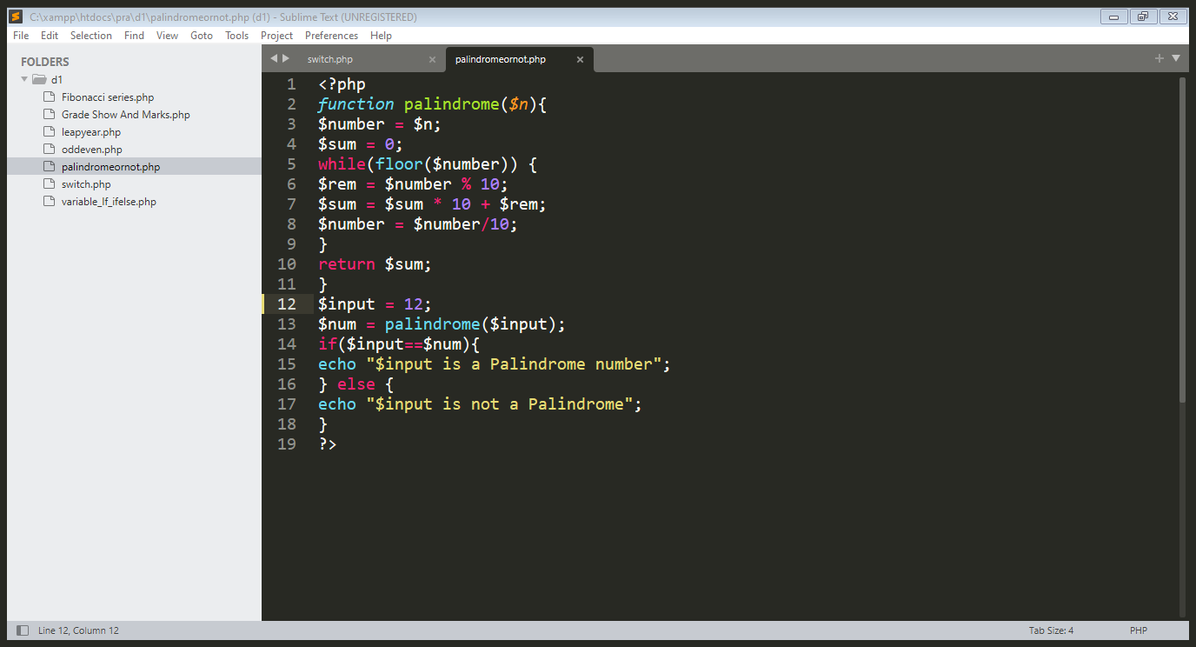Output

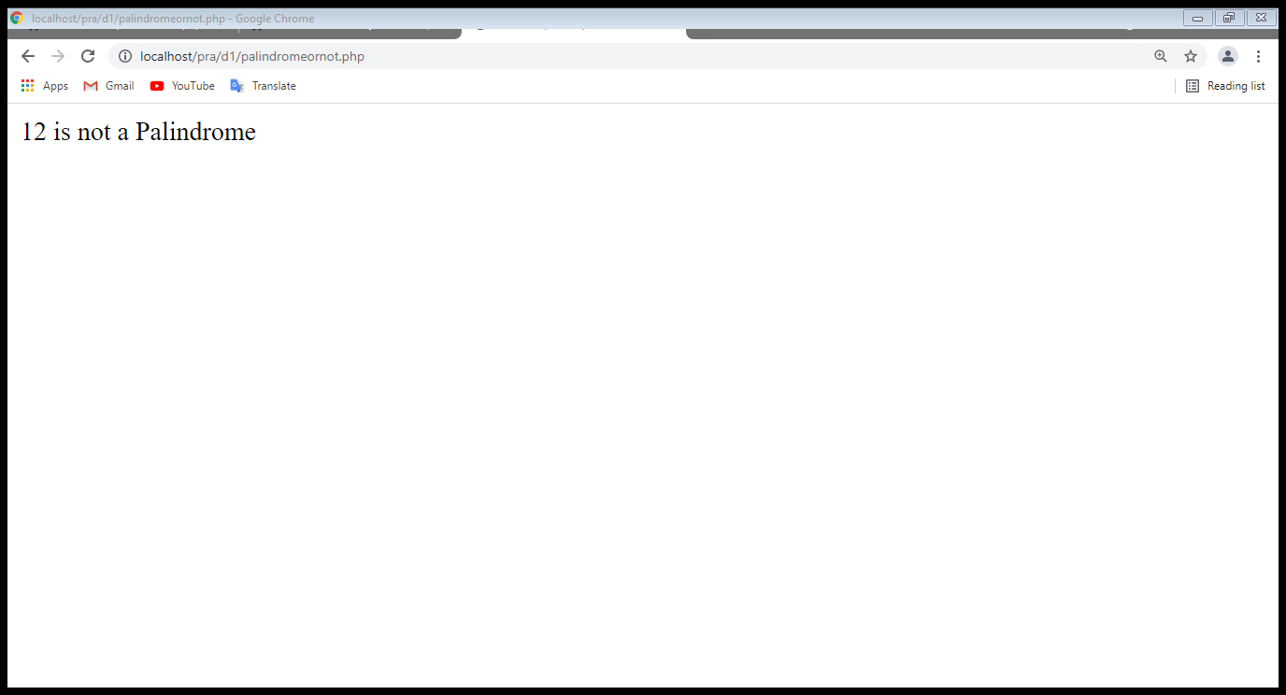

## Day 3

### Students Marks Entry Form Using PHP

### For Loop program using Table Tag

### Registration Form Using get and post method

Students Marks Entry

Code: <https://github.com/Rameshwar-Ishnava/PHP-internship/blob/main/Day%203/result.html>

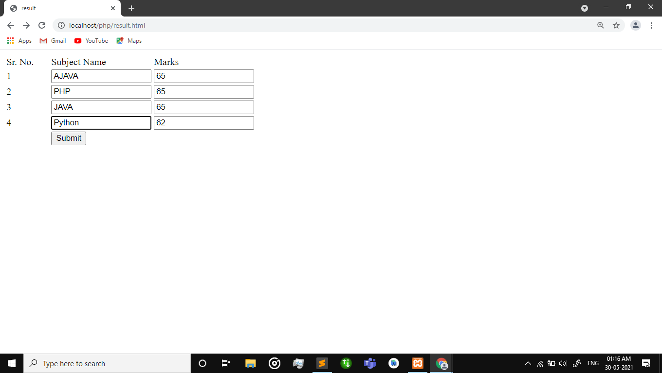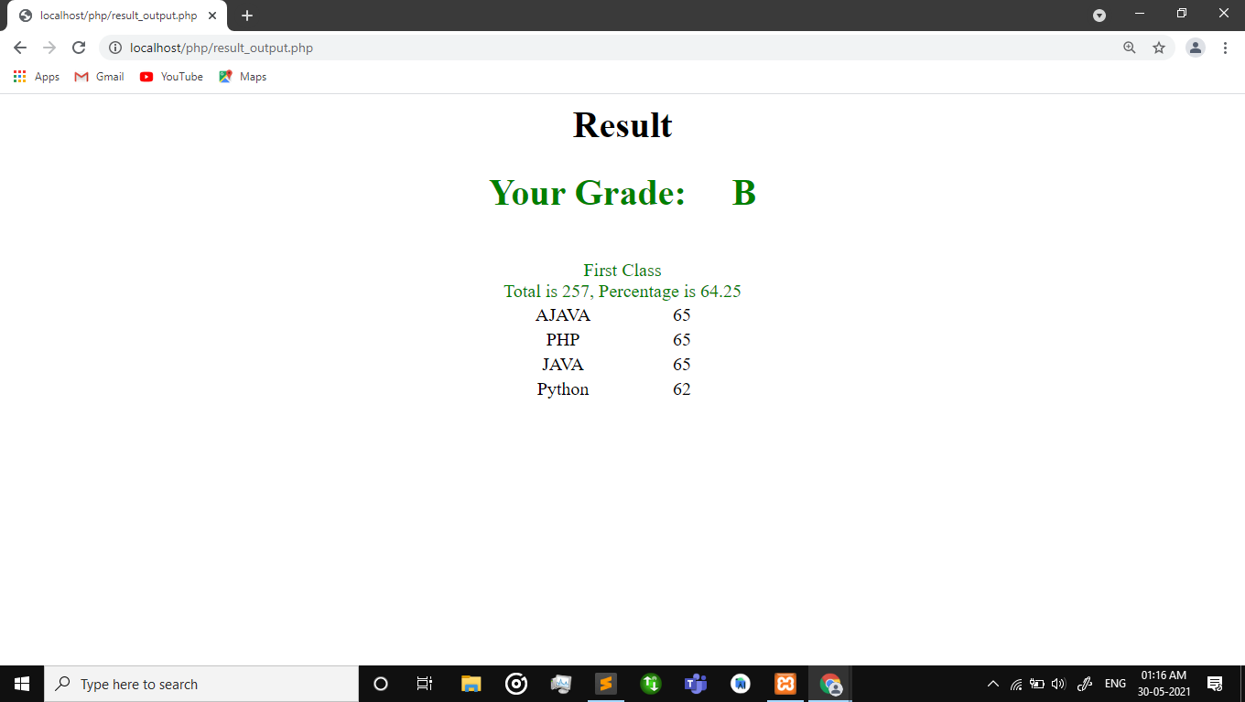

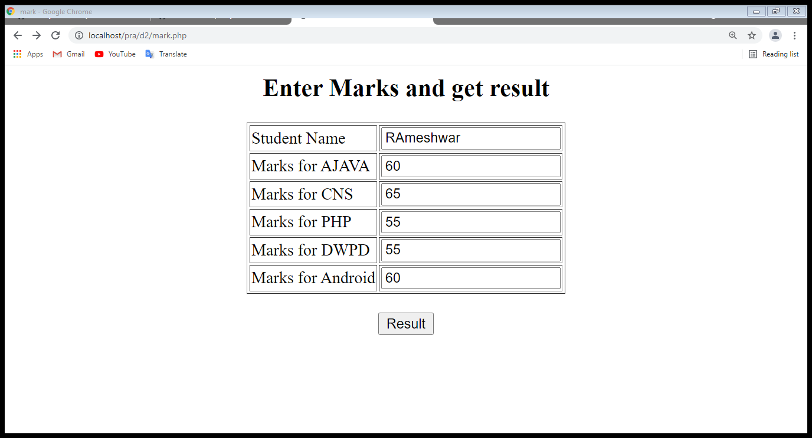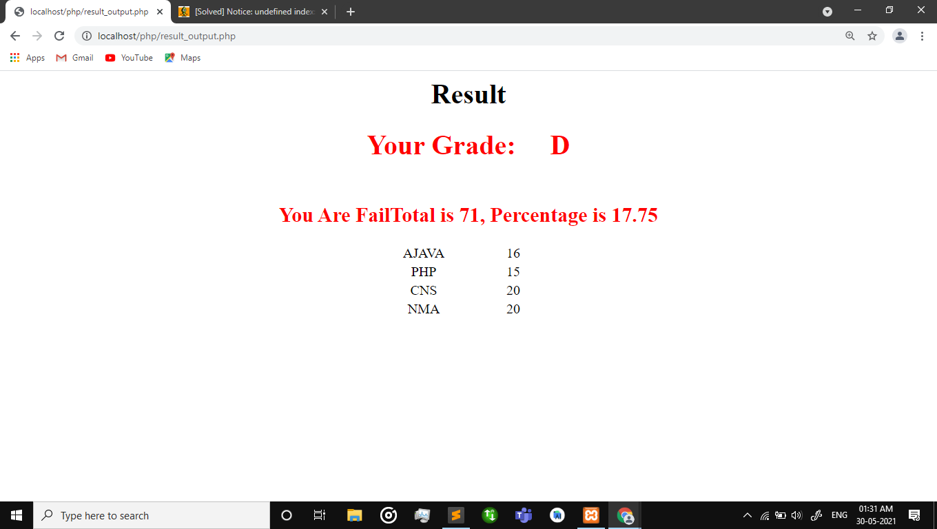

<https://github.com/Rameshwar-Ishnava/PHP-internship/blob/main/Day%203/mark.php>

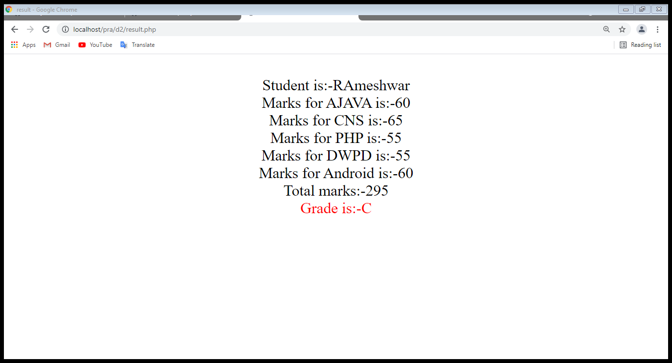

Code: <https://github.com/Rameshwar-Ishnava/PHP-internship/blob/main/Day%203/table%20using%20for%20loop.php>

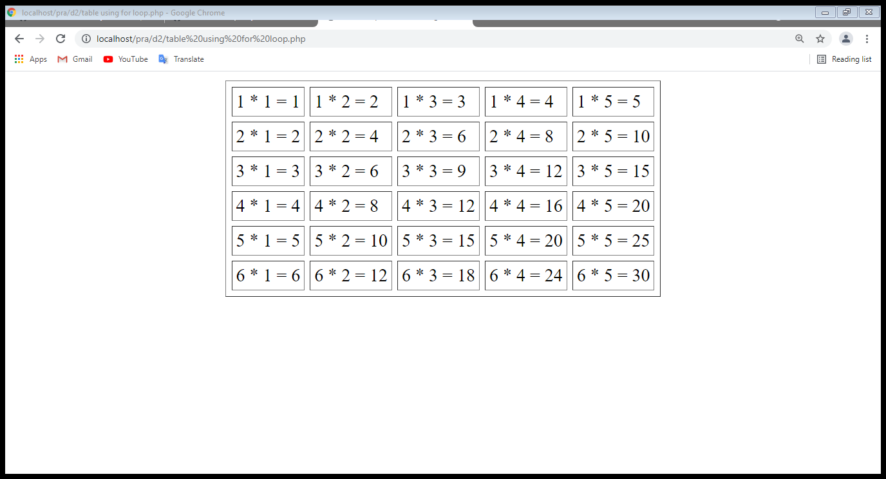

Registration from using get and post

Code: <https://github.com/Rameshwar-Ishnava/PHP-internship/blob/main/Day%203/Registration_Form.php>

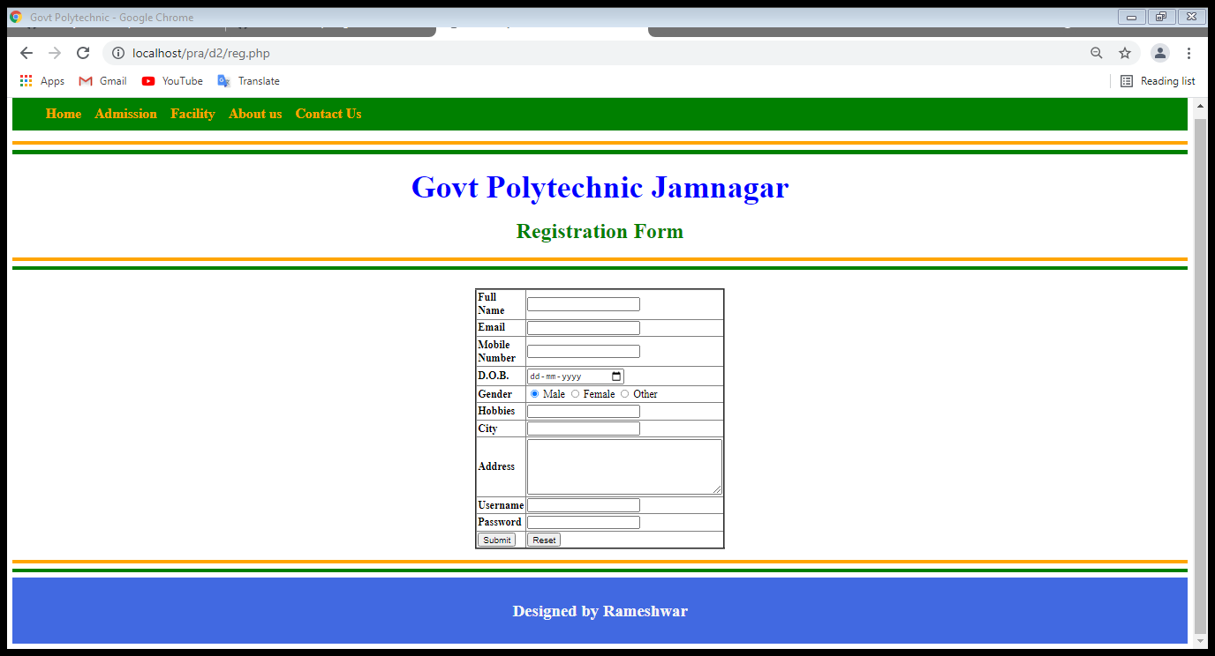

## Day 4

### PHP Template Integration

Code:<https://github.com/Rameshwar-Ishnava/PHP-internship/tree/main/Day%204/template1>

Home page

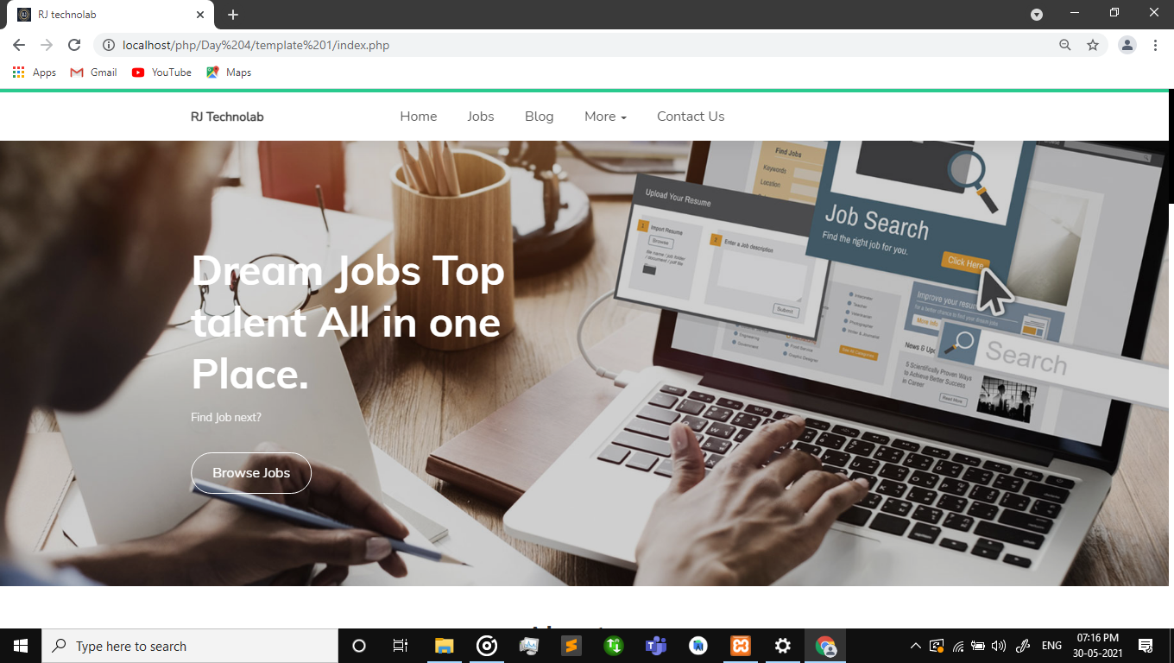

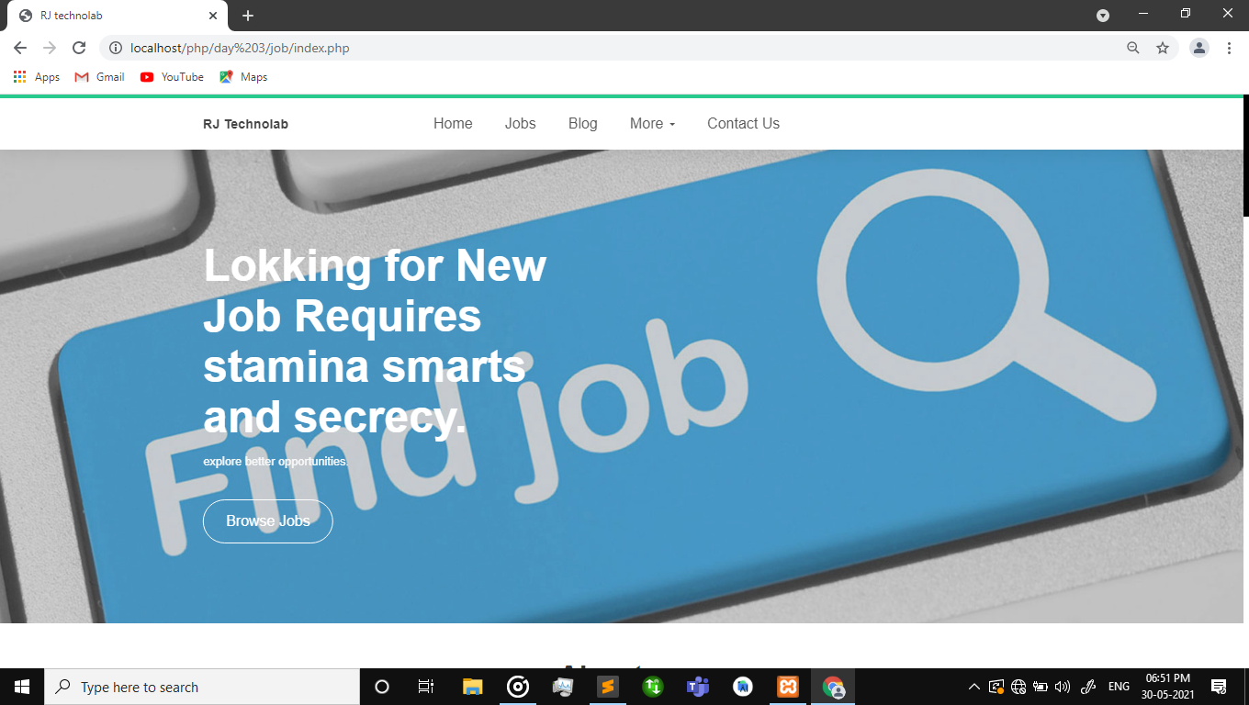

Jobs menu

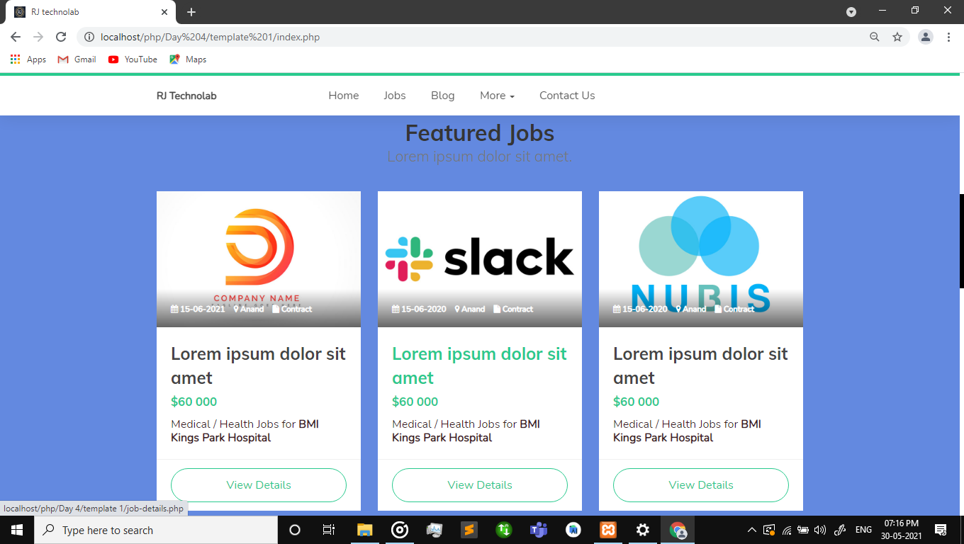

Blog menu

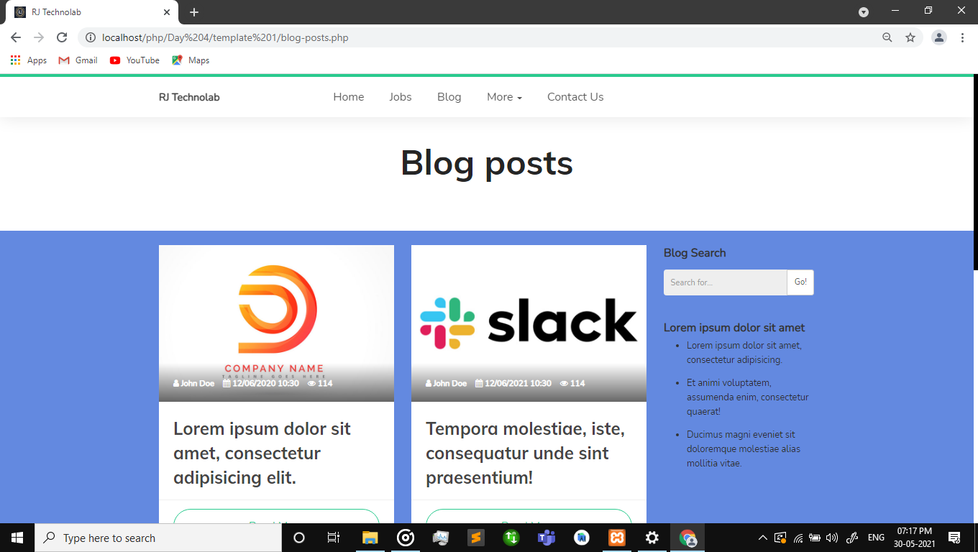

Contact us

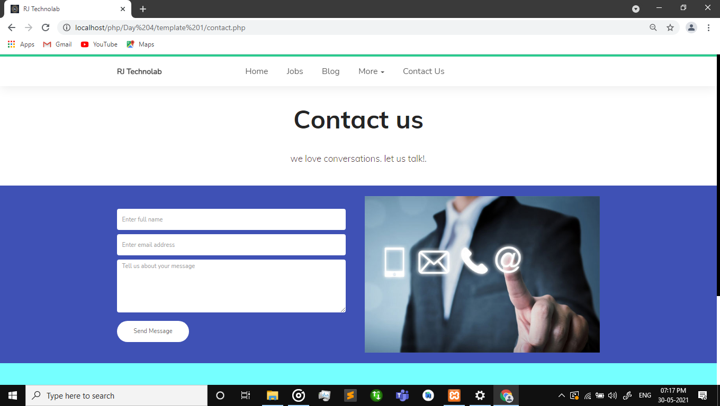

Footer and header

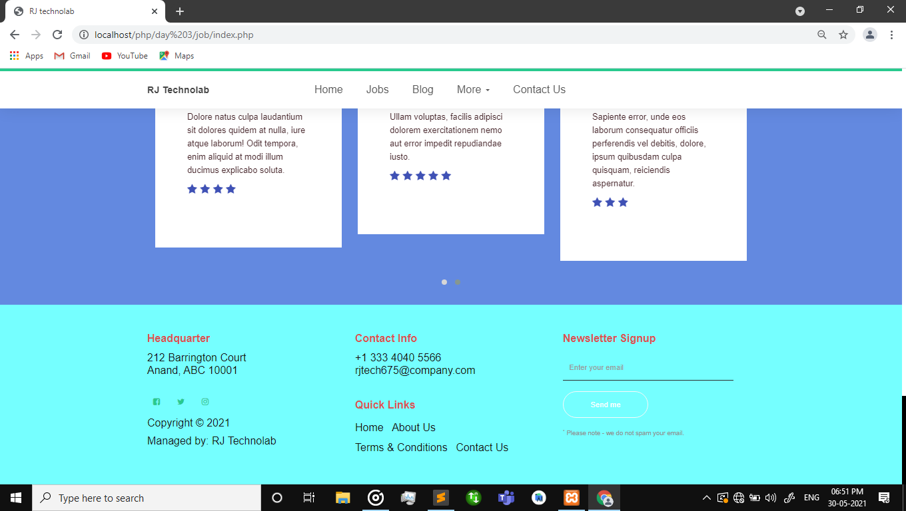

## Day 5 & 6

### Remaining work in Template 1 & 2

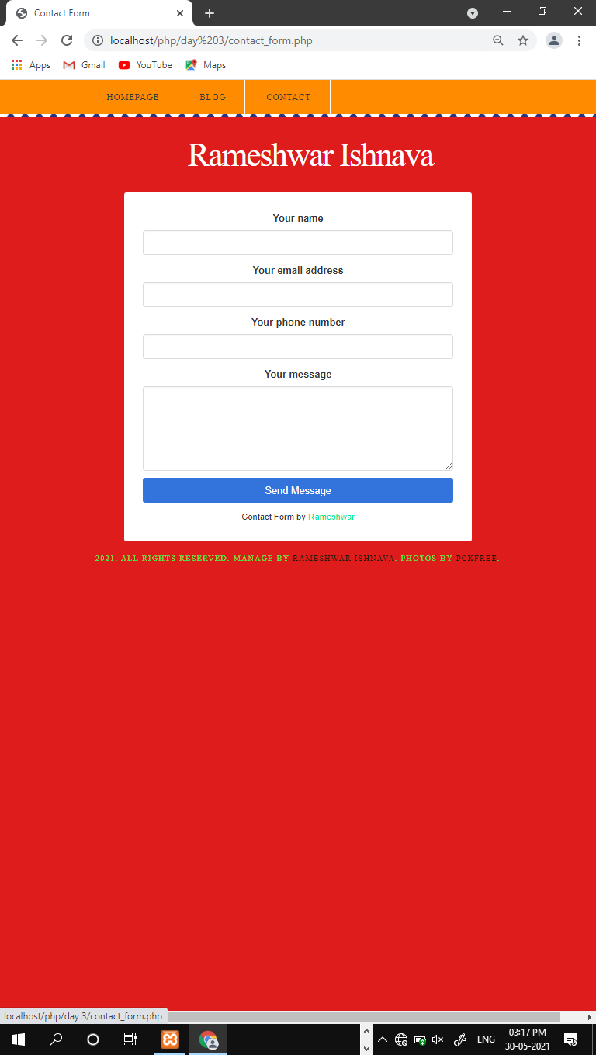code:<https://github.com/Rameshwar-Ishnava/PHP-internship/tree/main/Day%204/template2/fcf-assests>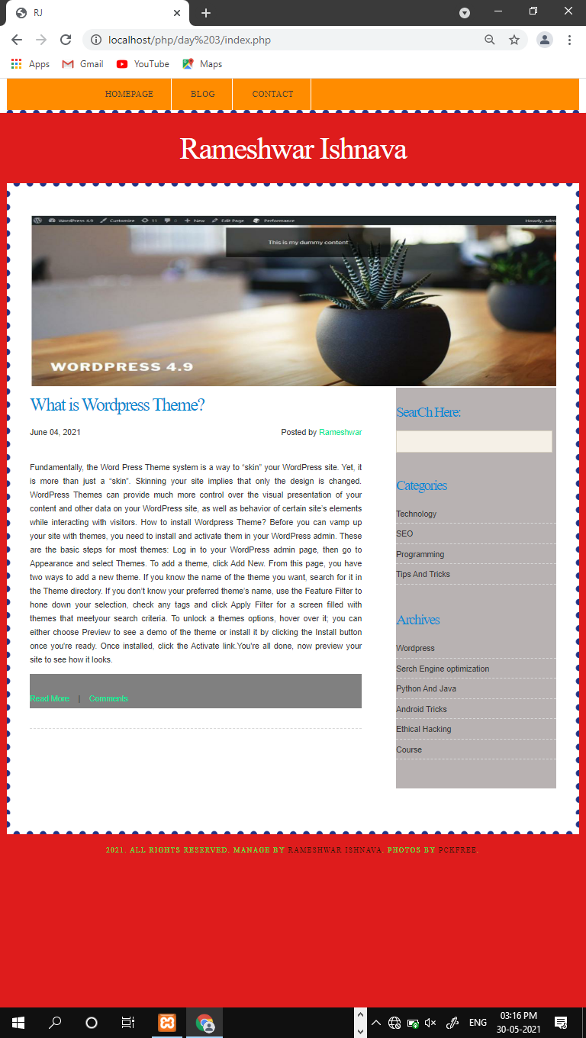

## Day 7

### Numerical , Associative Array

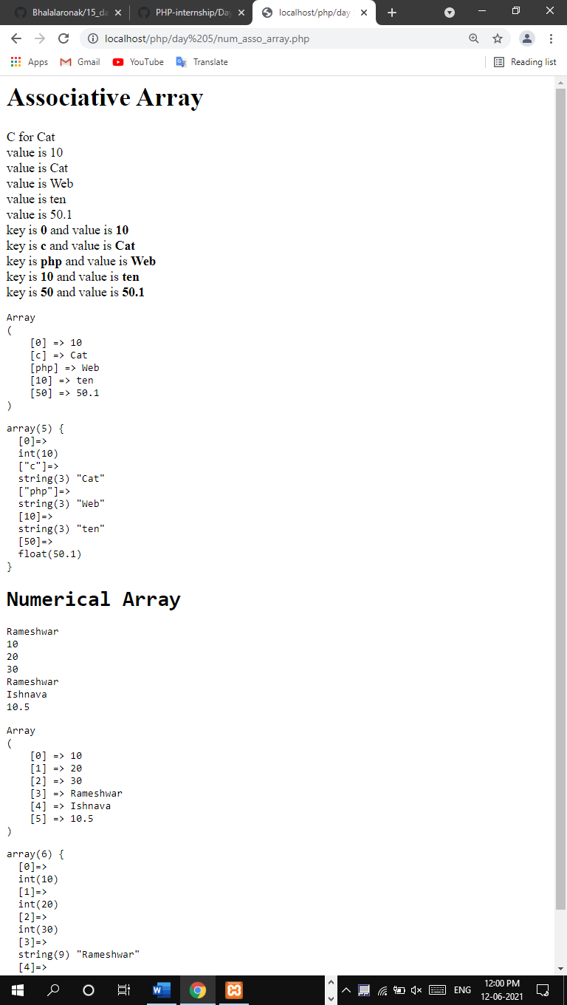

## Day 8

### Database connection ,insertion operation

### perform insertion operation without theme

### perform insertion operation with theme

**connection create**

<?php

define('DB_SERVER', 'localhost');

define('DB_USERNAME', 'root');

define('DB_PASSWORD', '');

define('DB_NAME', 'demo');

/* Attempt to connect to MySQL database */

$link = mysqli_connect(DB_SERVER, DB_USERNAME, DB_PASSWORD, DB_NAME);

if($link === false){

die("ERROR: Could not connect. " . mysqli_connect_error());

}?>

With out theme

Code: <https://github.com/Rameshwar-Ishnava/PHP-internship/blob/main/Day%206/data%20insert%20without%20theme%20in%20database/insert%20data%20in%20database.php>

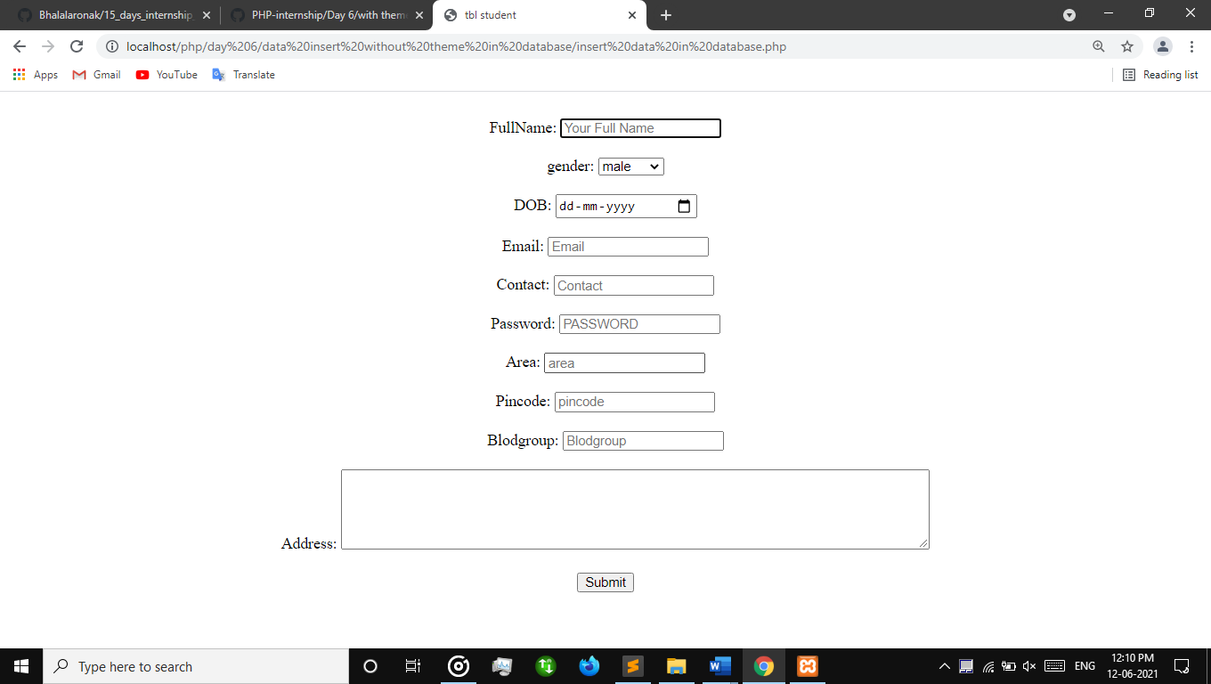

With theme

Code : <https://github.com/Rameshwar-Ishnava/PHP-internship/tree/main/Day%206/with%20theme%20data%20insert%20in%20databse>

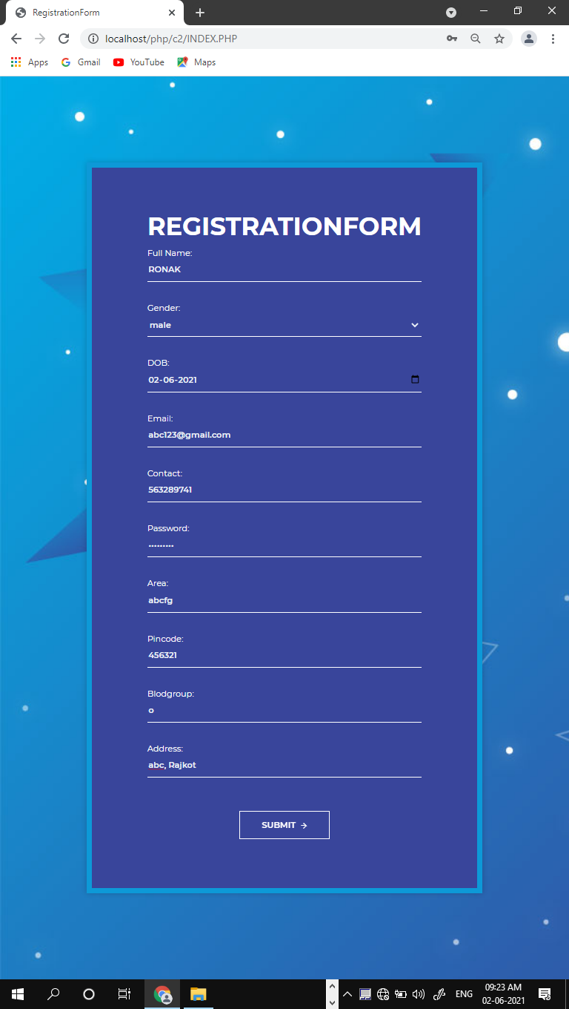

## Day 9 & 10

### select, delete & update query

### fetching data from database

### redirection on page

### update query and embed into theme.

### Perform update operations on table

Code : <https://github.com/Rameshwar-Ishnava/PHP-internship/tree/main/Day%207>

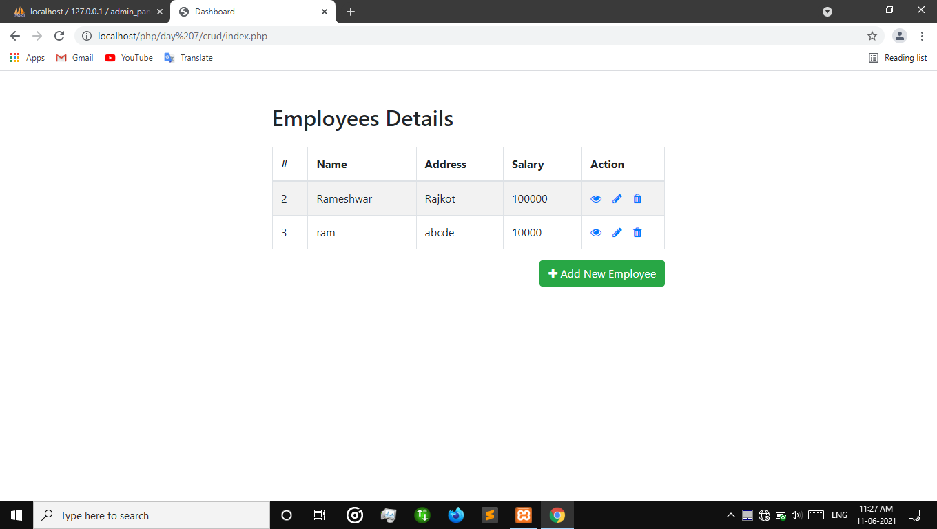

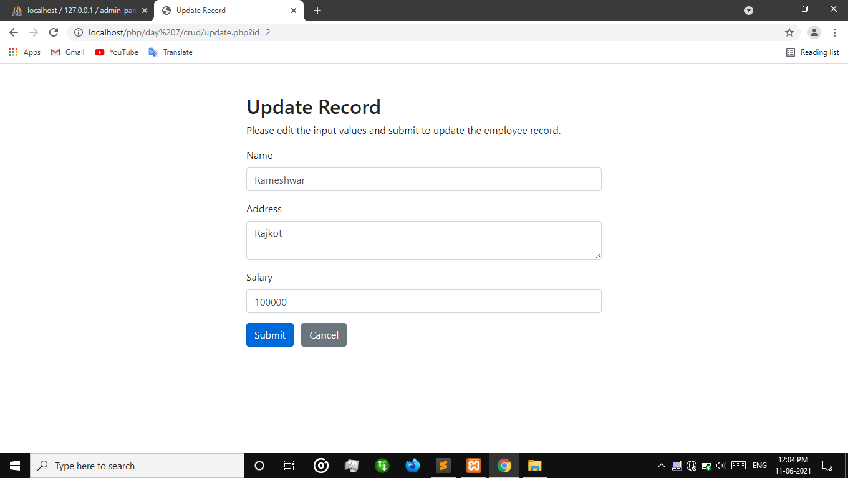

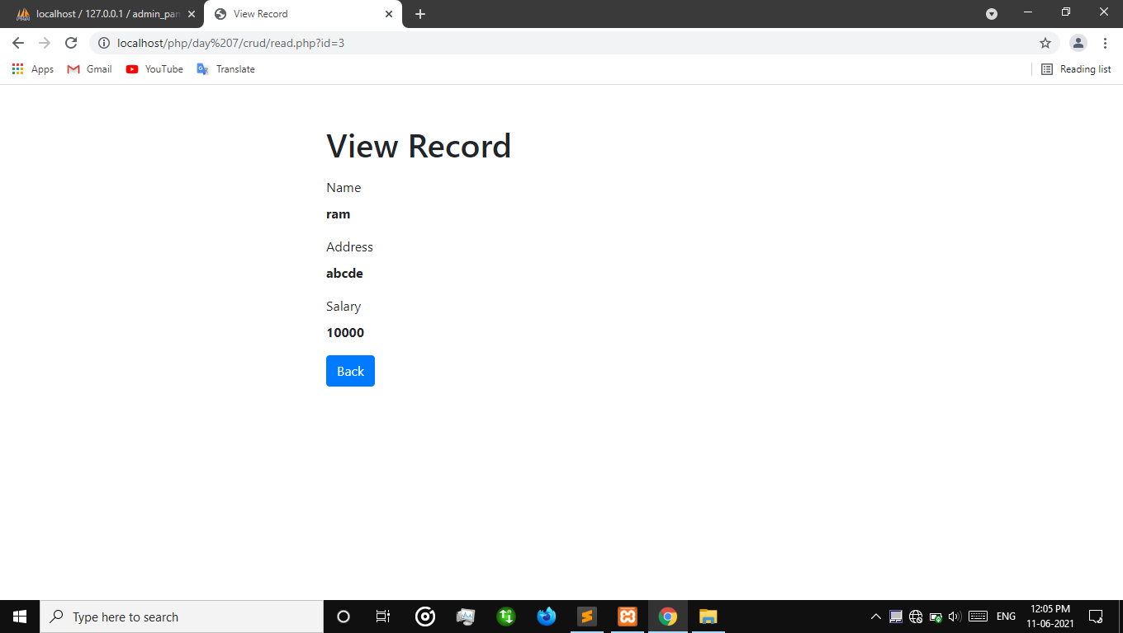

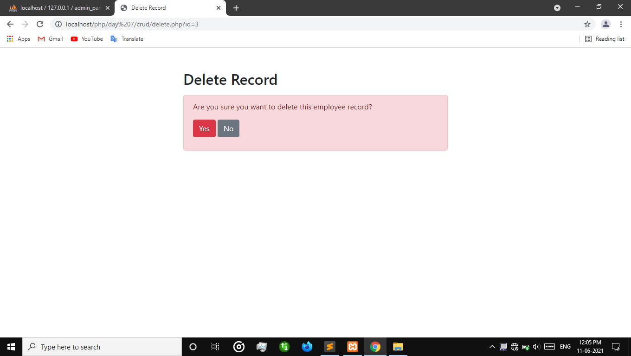

## Day – 11 ,12, 13,14, 15

### Installation and learing about wordpress

### Features and defects of wordpress

### undarstanding a wordpress development environment.

### simple blog creation using wordpress

### Installation of plugins and use of it

### menus creation in theme

### Theme customization and development in wordpress

### Remaining work completion

### Task uplodation work on git

### Editing on wordpress site

**Step-1:** download wordpress

**Step 2:** Search Wordpress

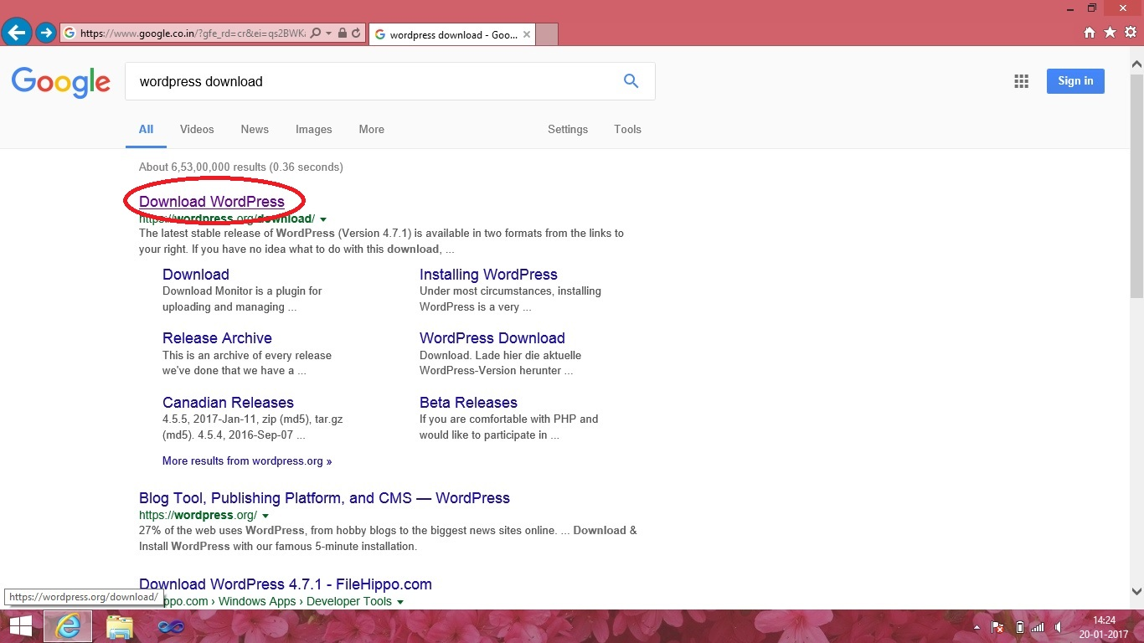

Here we have searched WORDPRESS for download and then click on any result to enter the website of WORDPRESS



**Step 3:** Download wordpress.

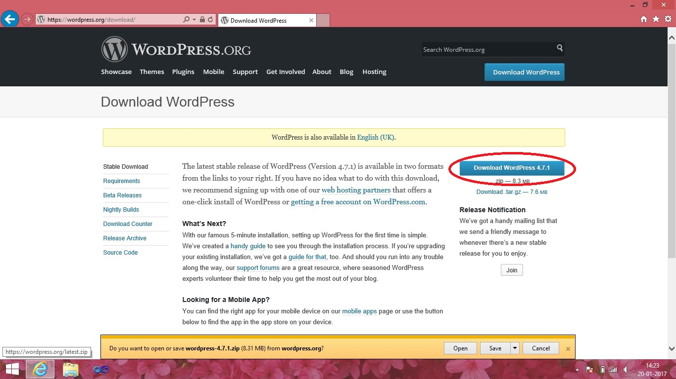

Click to download button and save the WORDPRESS zip file to your drive location where you want to store. After downloading extract the file.

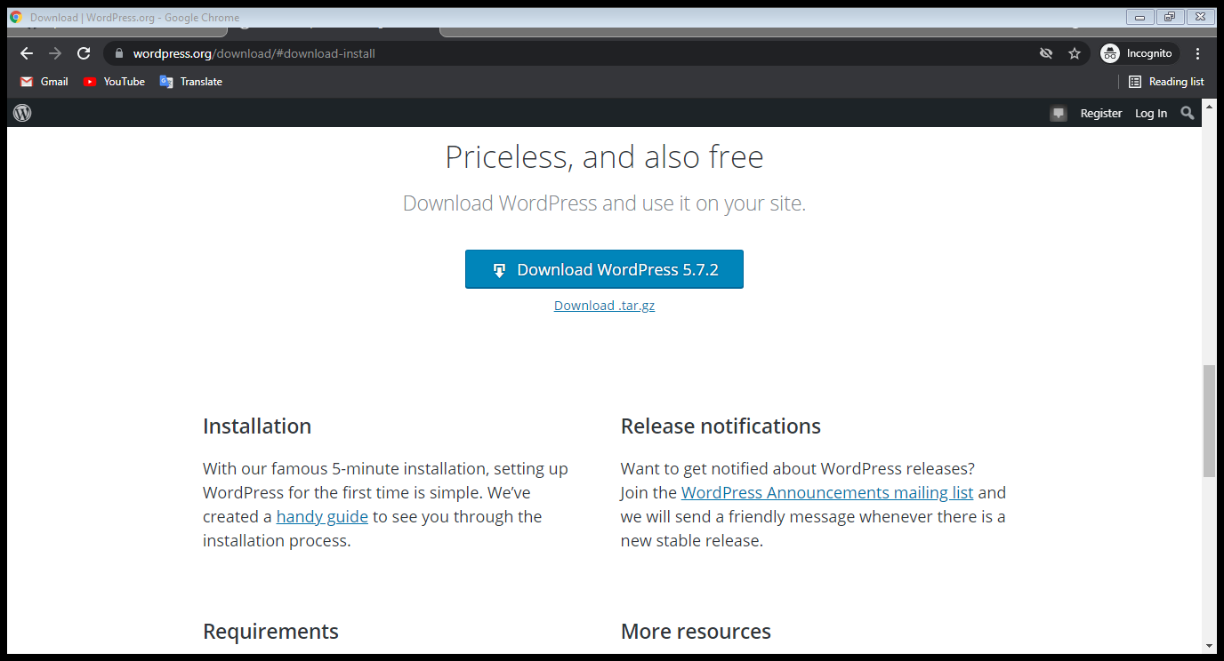

**Step 4:** copy the extracted file

After extracting the WORDPRESS files. Copy the WORDPRESS folder.

**Step 5:** open xampp control panel.

Start Apache server and then start MySQL database system.

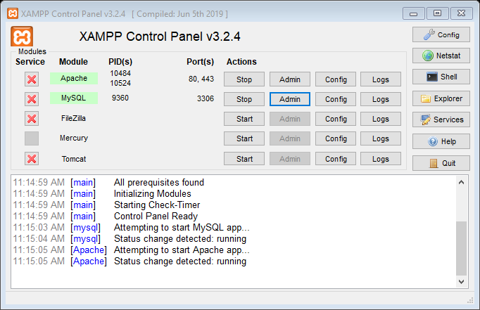

Then minimize the XAMPP control panel.

**Step 6:** open web browser

Type “localhost” on URL and then press enter button.

**Step 7:** XAMPP dashboard.

Then page will open of XAMPP dashboard. Click on to **“phpMyAdmin”**.

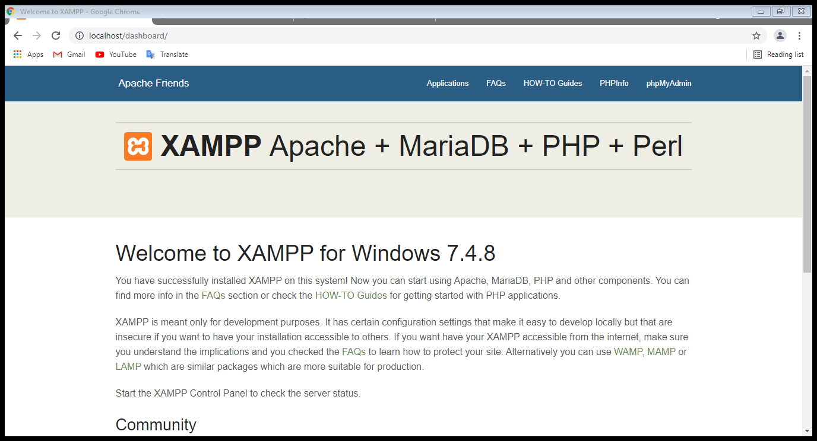

**Step 8:** create a database

The page “phpMyAdmin” will open. Click on **“Databases”** to create the database

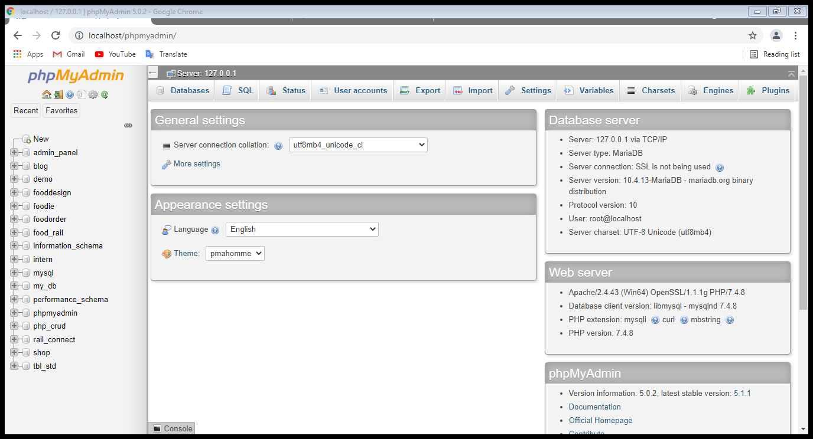

Click on to textbox to give database name. Here given name is **“MyNewDatabase”**. You can give any name as per your choice. And then click on **“create”** button to create your own database.

**Step 9:** paste WORDPRESS

After extracting the WORDPRESS file. Copy the WORDPRESS folder. Open C drive >> XAMPP folder. Paste the WORDPRESS folder into **“htdocs”** folder.

**Step 10:** open web browser.

Then switch to web-browser and type into URL **“localhost/wordpress”**

Click to enter button

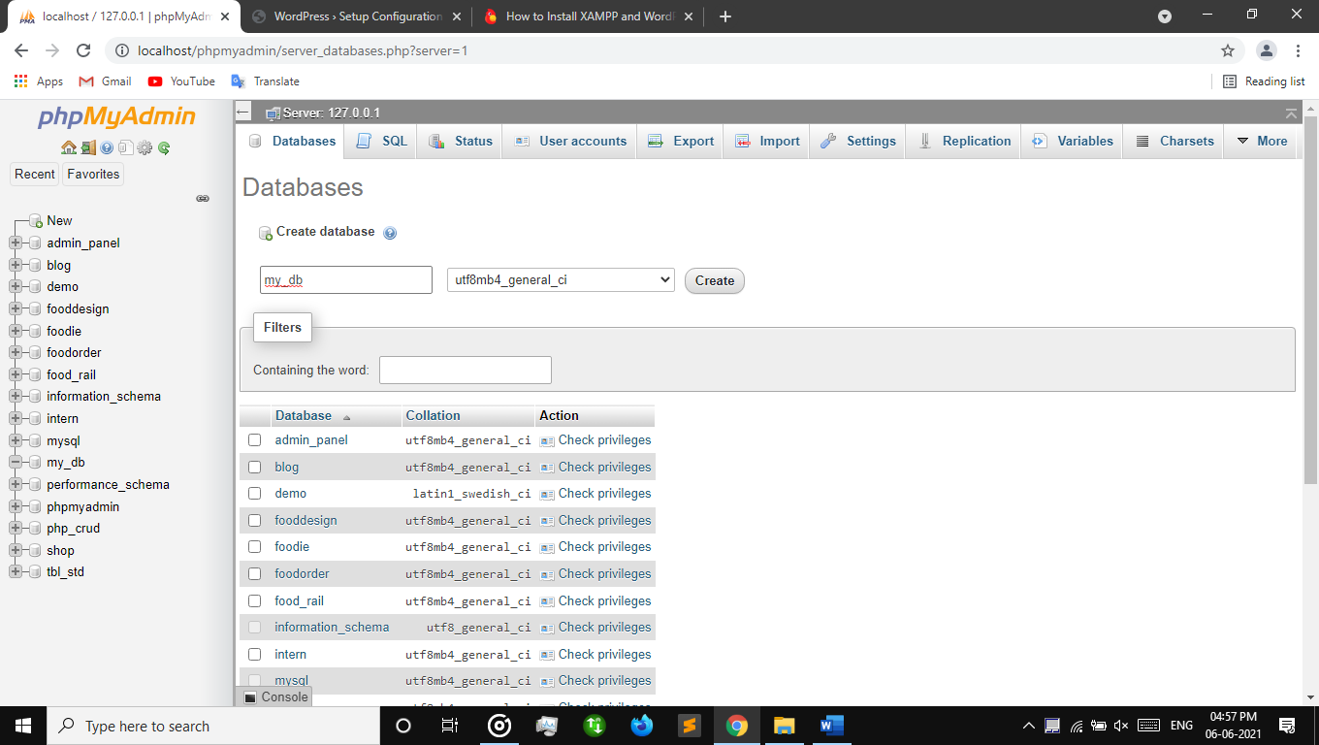

Here WORDPRESS will open. Click to **“Let’s go!”** button.

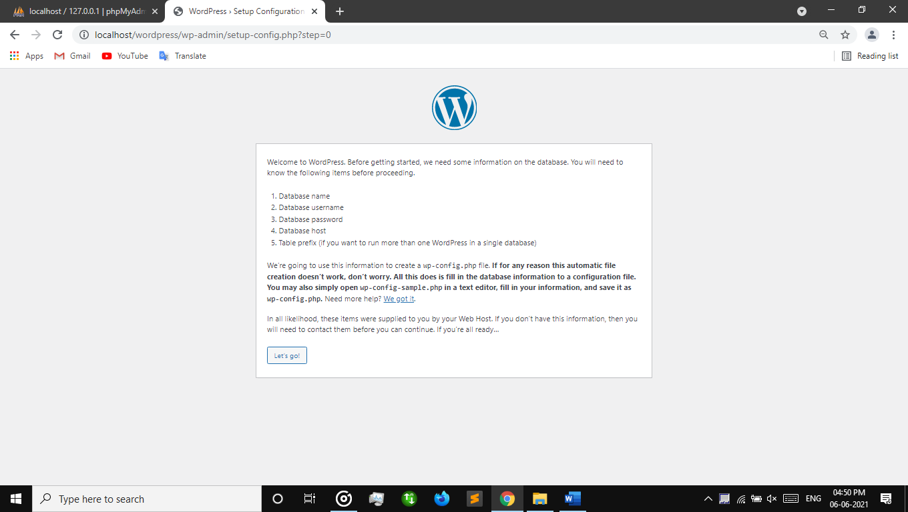

Here form will appear before you. Give database name where you created in “phpMyAdmin”. In this case the database name is **“MyNewDatabase”**. Type **“root”** into username. Do not provide any kind of password into password-box. Then click to **“submit”** button

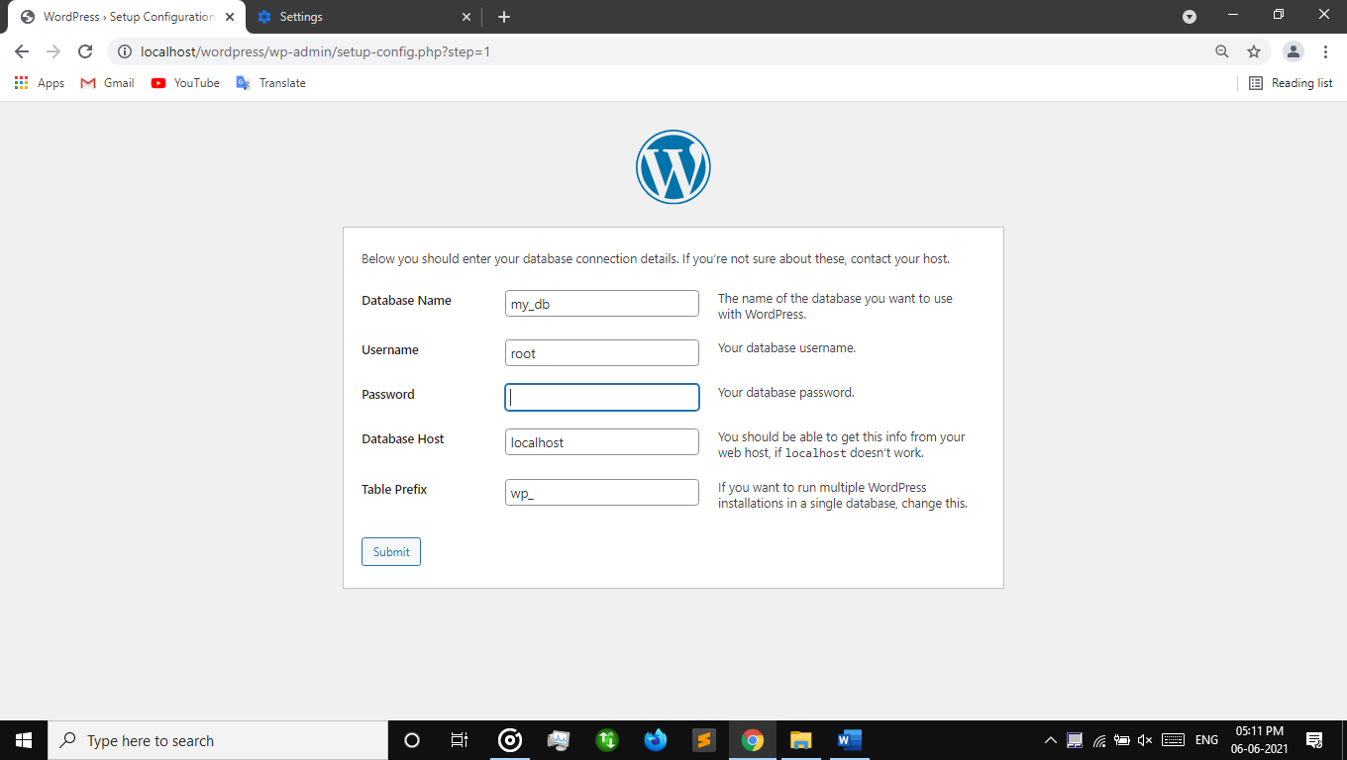

**Step 11:** **“Run the Install”**

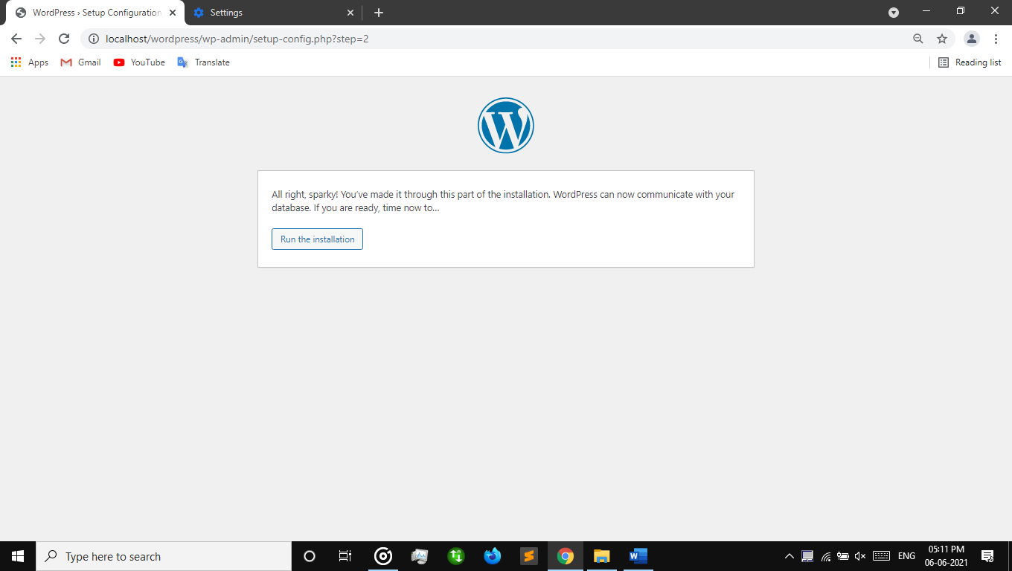

**Step 12:** sign in

Fill the necessary information in the boxes.

Here…

Site title:- MyFirstWeb

Username:- ram (give username what you prefer)

Password:- enter password for security

Confirm the checkbox

Fill your email address (it is compulsory)

Then hit on **“Install Wordpress”**

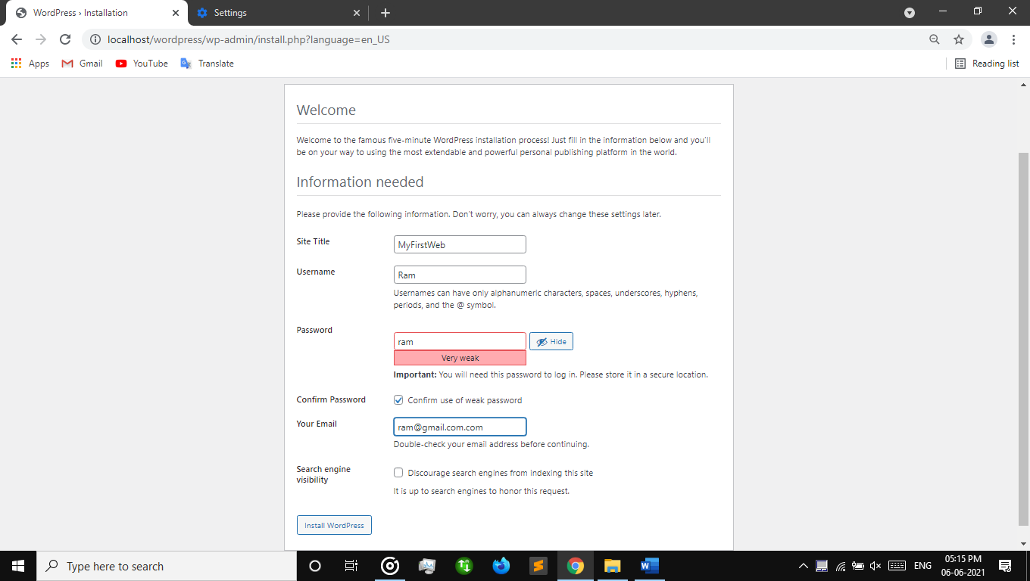

**Step 13:** Login

Give username and password

Press **“Log In”** button.

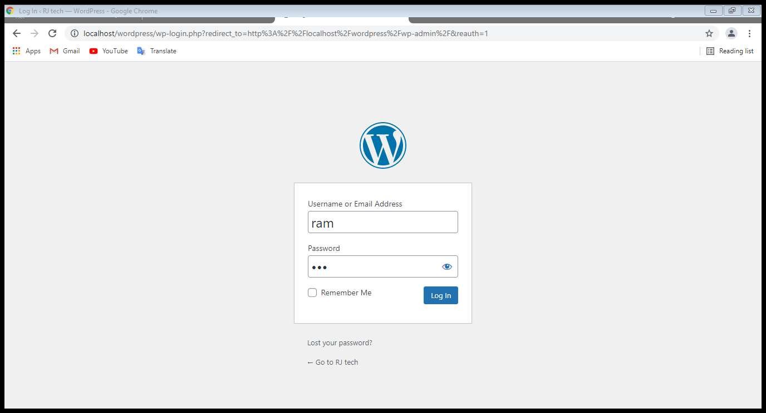

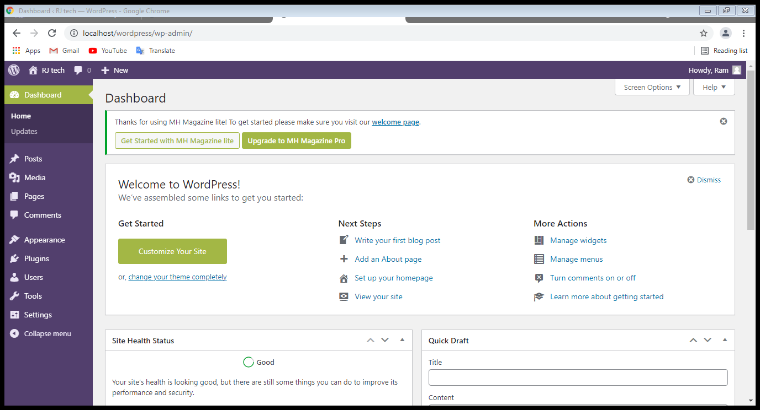

**Post create and publish**

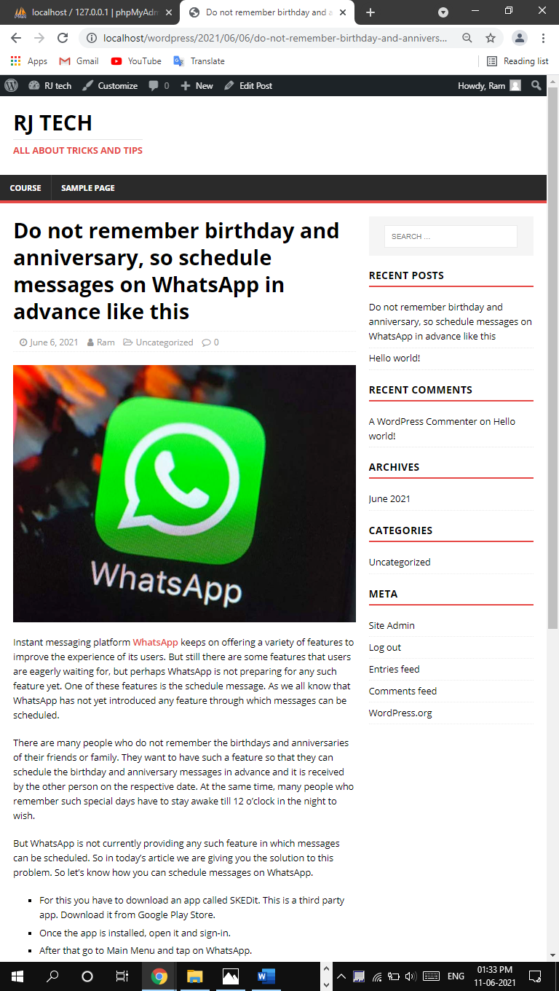

**Post edit**

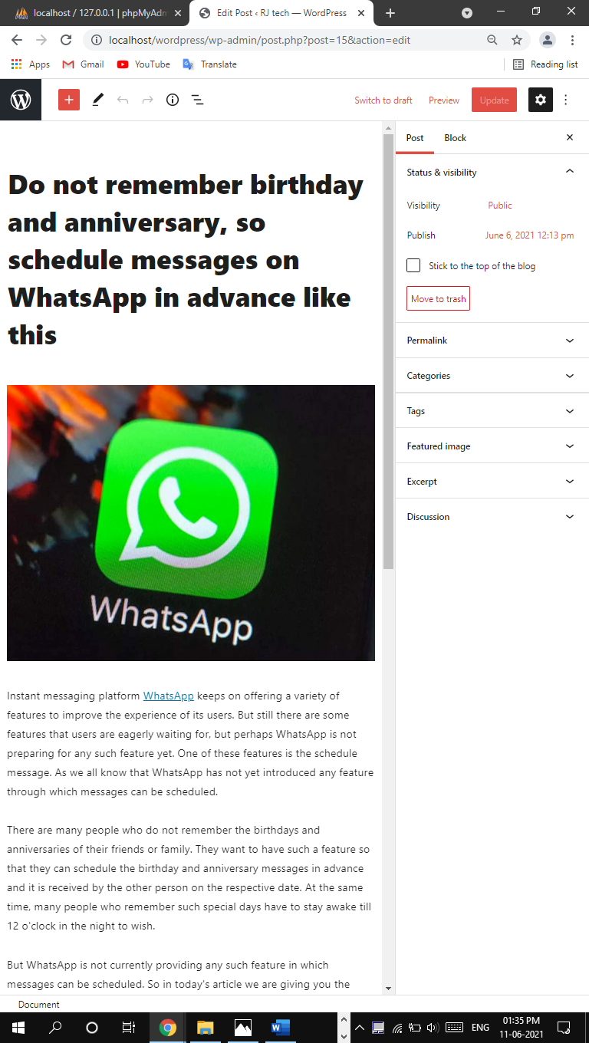

**Plugin**

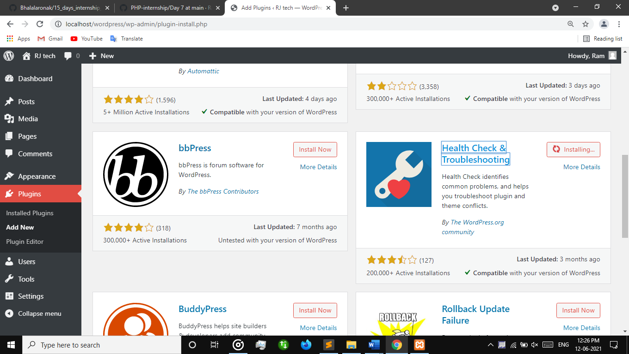

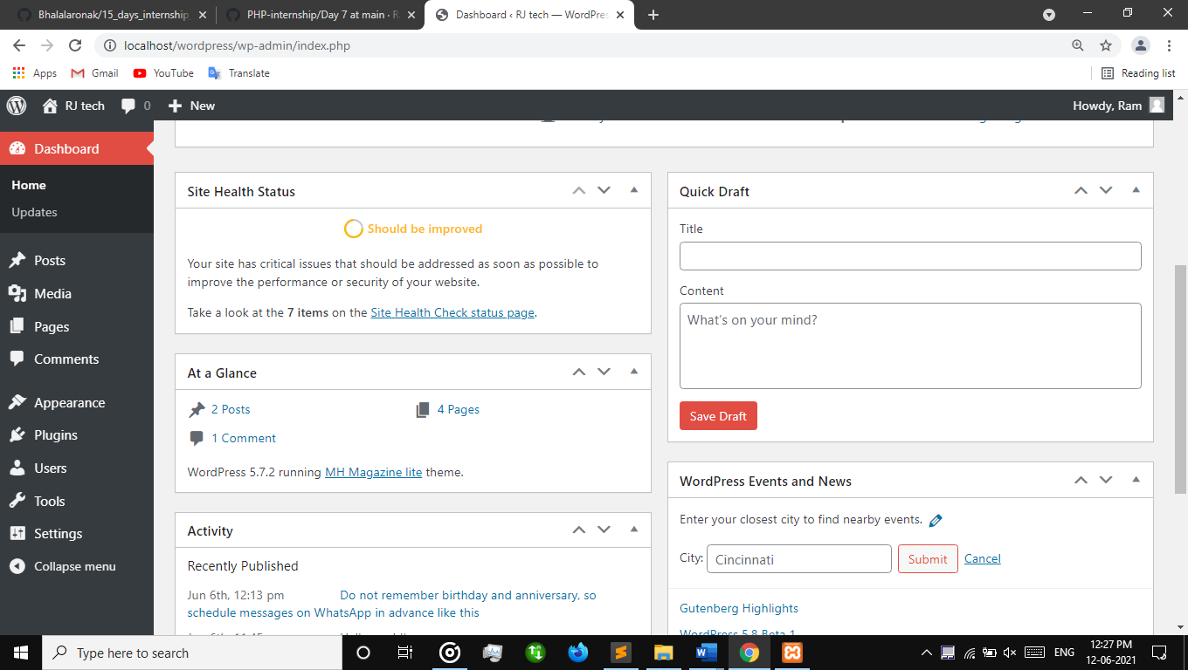

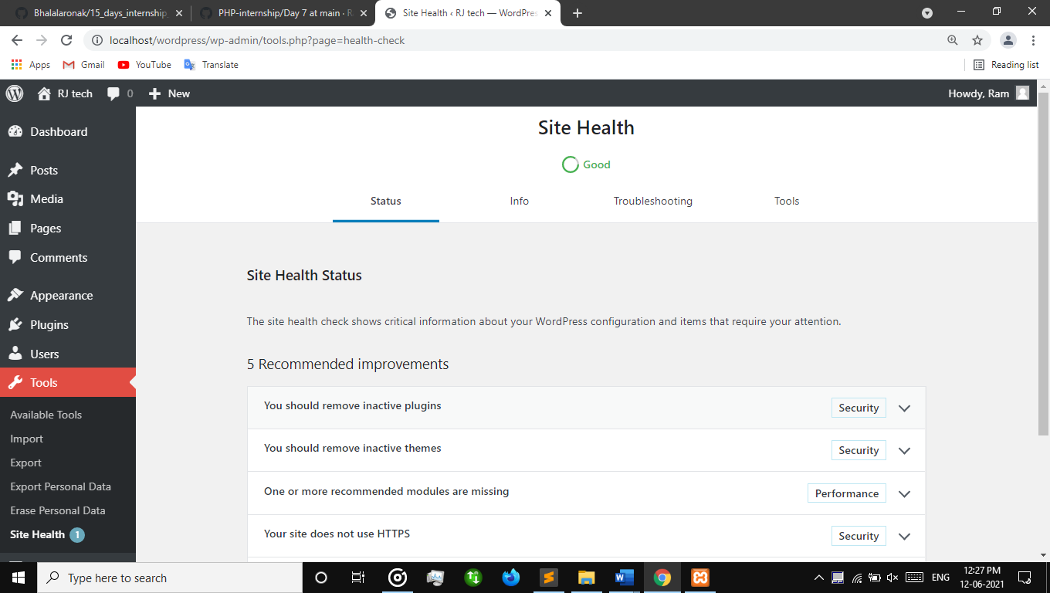

**Theme Customize**

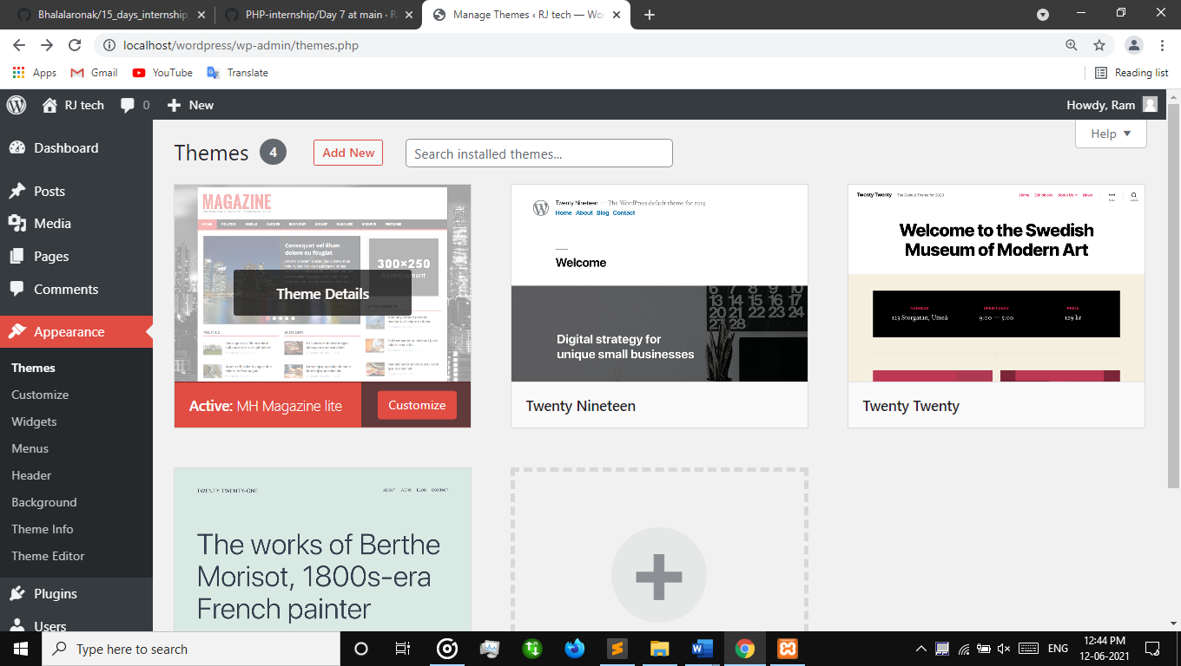

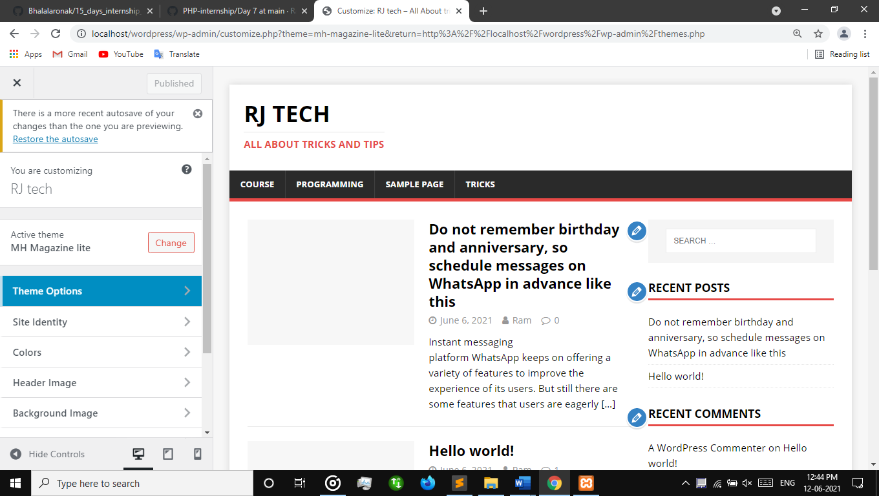

**Menu customize**

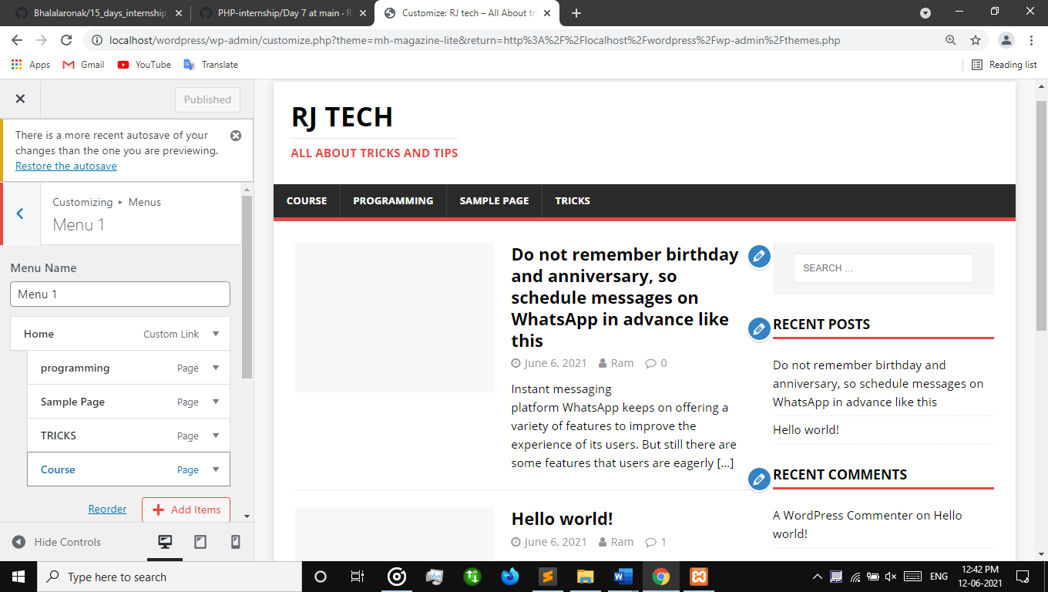

**Home page**

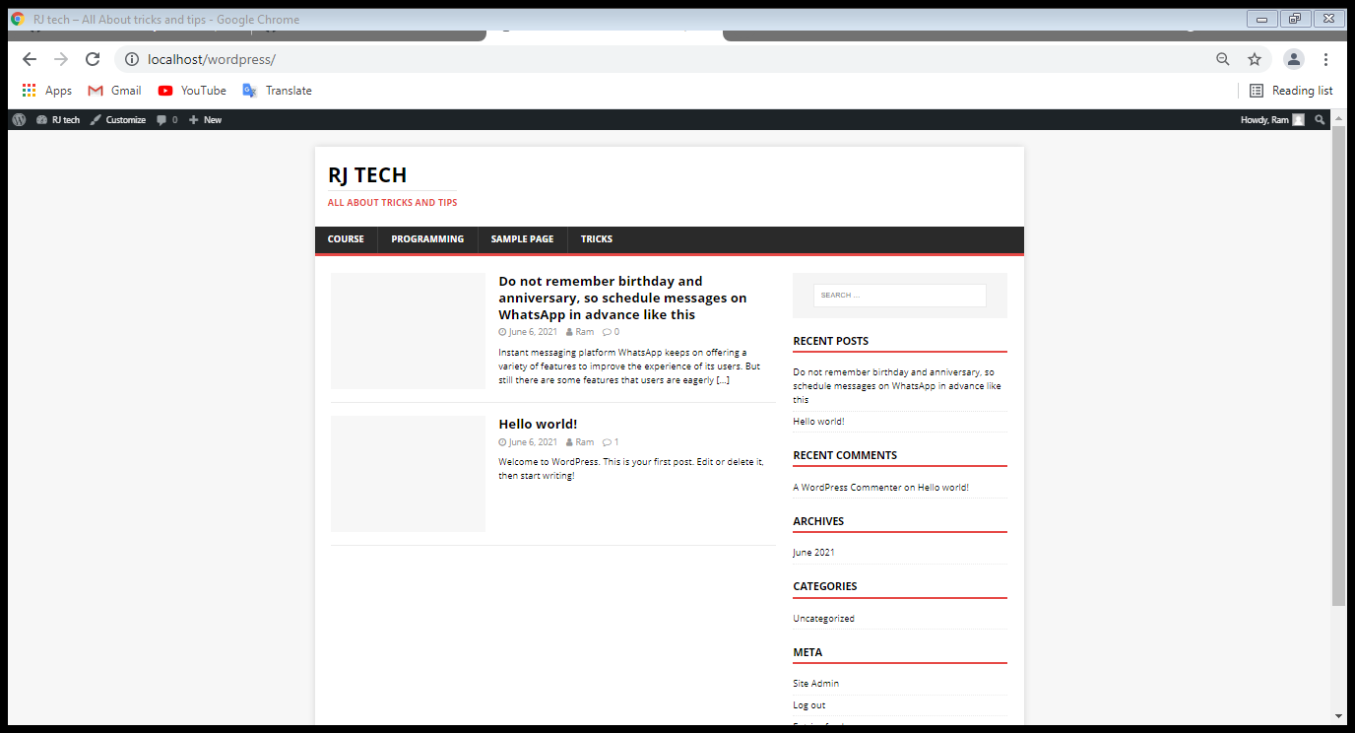

Recent post

